

**ASSIGNMENT COVER SHEET**

|  |  |  |  |  |
| --- | --- | --- | --- | --- |
| PROGRAMME | : | Bachelor of Business Analytics (Hons) | | |
| SUBJECT CODE AND TITLE | : | BAA3114 Web Design and Development | | |
| ASSIGNMENT TITLE | : | Final Assessment | | |
|  |  |  | | |
| LECTURER | : | Dr Muaadh | ASSIGNMENT DUE DATE: | 04/01/2026 |

STUDENT’S DECLARATION

1. I hereby declare that this assignment is based on my own work except where acknowledgement of sources is made.
2. I also declare that this work has not been previously submitted or concurrently submitted for any other courses in Sunway University/College or other institutions.

[ Submit “Turn-it-in” report (please tick √): Yes _____ No _____ ]

|  |  |  |  |  |
| --- | --- | --- | --- | --- |
| NO. | NAME | STUDENT ID NO. | SIGNATURE | DATE |
| 1. | Yaw Chin Hen | 21058417 | ChinHen | 30/12/2025 |
| 2. | Yang Ka Weng | 21095872 | Ykw | 30/12/2025 |
| 3. | Tam Sze Yin | 21093893 | Sam | 30/12/2025 |
| 4. | Sara Nabilah Shamsul Baharin | 19013333 | Sara | 03/01/2026 |
| 5. |  |  |  |  |
| 6. |  |  |  |  |

E-mail Address / Addresses (according to the order of names above):

|  |  |
| --- | --- |
| 1. [21058417@imail.sunway.edu.my](mailto:21058417@imail.sunway.edu.my) | 4. [19013333@imail.sunway.edu.my](mailto:19013333@imail.sunway.edu.my) |
| 2. [21095872@imail.sunway.edu.my](mailto:21095872@imail.sunway.edu.my) | 5. |
| 3. [21093893@Imail.sunway.edu.my](mailto:21093893@Imail.sunway.edu.my) | 6. |

APPROVAL FOR LATE SUBMISSION OF ASSIGNMENT (If applicable)

IF extension is granted, what is the revised due date? ______________________________________________

Signature of Lecturer: ______________________________________ Date: ____________________________

|  |
| --- |
| Marker’s Comments: |

Marks and / or Grade Awarded: _____________________________ Date:____________________________

**ADDENDUM**

**USE OF ARTIFICAL INTELLIGENCE (A.I.) DECLARATION**

Students are allowed to use AI to support completion of assessments. However, students are reminded to do so ethically and transparently. This is so that (a) submissions can be fairly and accurately marked; and (b) feedback can be provided on the content that reflects student ability, in order to help with future submissions. Students are also reminded that in accordance with the University’s Academic Malpractice Policy, Item 4.11.2, “*… the representation of work: written, visual, practical or otherwise, of any other person, including another student or* ***anonymous web-based material*** *[emphasis added], or any institution, as the candidate’s own*” is considered malpractice.

**Declaration**

[ / ] I / We used the following A.I. tools to produce content in this submission:

|  |  |  |  |
| --- | --- | --- | --- |
| **Tool** | **Purpose** | **Prompts** | **Sections where AI output was used / Outcome(s) in the submission** |
| Grammarly | Correcting grammar and spelling, improving sentence structure | N/A | Grammarly suggestions were used for all sections of the essay |
|  |  |  |  |
|  |  |  |  |
|  |  |  |  |

*Note: Add additional rows if necessary.*

**OR**

[ ] I / We did not use any A.I. tools to produce any of the content in this submission.

|  |  |  |  |  |
| --- | --- | --- | --- | --- |
| NO. | NAME | STUDENT ID NO. | SIGNATURE | DATE |
| 1. | Yaw Chin Hen | 21058417 | ChinHen | 30/12/2025 |
| 2. | Yang Ka Weng | 21095872 | Ykw | 30/12/2025 |
| 3. | Tam Sze Yin | 21093893 | Sam | 30/12/2025 |
| 4. | Sara Nabilah Shamsul Baharin | 19013333 | Sara | 03/01/2026 |
| 5. |  |  |  |  |
| 6. |  |  |  |  |

E-mail Address / Addresses (according to the order of names above):

|  |  |
| --- | --- |
| 1. [21058417@imail.sunway.edu.my](mailto:21058417@imail.sunway.edu.my) | 4. [19013333@imail.sunway.edu.my](mailto:19013333@imail.sunway.edu.my) |
| 2. [21095872@imail.sunway.edu.my](mailto:21095872@imail.sunway.edu.my) | 5. |
| 3. [21093893@Imail.sunway.edu.my](mailto:21093893@Imail.sunway.edu.my) | 6. |

**Table of Contents**

1. Introduction 6

1.1 Background of the Study 6

1.2 Project Purpose 6

1.3 Project Objectives 7

1.4 Scope of the Project 7

2. Requirement Analysis 8

2.1 Project Scope and System Overview 8

2.2 Target Users 9

2.3 Problem Identification 9

2.4 Business Process Flow 10

2.5 Tools and Technologies Used 11

2.6 Database Requirements 11

2.7 Project Timeline 12

3. System Design 13

3.1 Overall System Architecture 13

3.1.1 Presentation Layer (Client Side) 13

3.1.2 Application Layer (Server Side) 13

3.1.3 Data Layer (Database) 14

3.2 Navigation Structure 15

3.2.1 Header-based Navigation 15

3.2.2 Dynamic State Mechanism 15

3.3 Wireframes / Mock-ups 17

3.3.1 Home Page 17

3.3.2 Login/register Page 18

3.3.3 Add Sales Page 19

3.3.4 View Sales Page 20

3.3.5 Dashboard Page 21

3.4 Database Design (ERD) 22

3.4.1 Architectural Overview 22

3.4.2 Schema Specifications and Attributes 23

3.4.3 Design Rationale: The Decoupled Approach 24

3.5 Security Design Considerations 24

3.5.1 Password Hashing 25

3.5.2. Verification 25

3.5.3. Prepared Statements (SQL Injection Prevention) 25

3.5.4 Output sanitisation (XSS Protection) 26

3.5.5 Authentication by Sessions 26

4. Development 27

4.1 System Workflow 27

4.2 Front-End Development 34

4.2.1 HTML Structure 34

4.2.2 CSS Styling and Responsiveness 35

4.2.3 JavaScript Validation 36

4.3 Back-End Development 36

4.3.1 Authentication Module 37

4.3.2 Sales Management (CRUD) 39

4.3.3 Dashboard Analytics 42

4.3.4 Export Functionality 43

4.4 Key Code Snippets (Explained) 44

5. Testing and User Acceptance 46

5.1 Test Plan 46

5.2 CRUD Evidence 47

5.2.1 Create (Add Sale) 48

5.2.2 Read (View Sales) 48

5.2.3 Update (Edit Sales) 49

5.2.4 Delete (Remove Sales) 49

5.3 Responsiveness Testing 49

5.3.1 Desktop View (width >1034px) 50

5.3.2 Mobile View (width <480px) 50

6. Implementation & User Guide 51

6.1 Installation Guide 51

6.2 User Guide 55

6.3 Developer Notes 59

6.3.1 Folder Structure 59

6.3.2 Key Files 60

6.3.3 Database Schema 60

6.3.4 Common Errors and Fixes 61

7. References 62

# 1. Introduction

## 1.1 Background of the Study

The swift digital transformation of the worldwide economy has crucially converted how businesses run their internal operations, yet numerous Small and Medium Enterprises (SMEs) in Malaysia still cling to conventional physical bookkeeping methods. These physical procedures, which frequently demand physical ledger books or unconnected spreadsheets, are gradually becoming a responsibility in a fast-paced market. The key issues of manual sales management include exposure to human error, long delays in calculating total revenue, and the possibility of physical information loss due to unexpected situations. As businesses expanding, the demand for a unified, web-based system becomes important to make certain that every transaction is reported precisely and is available at once from any approved device (Ammeran et al., 2022).

On top of that, nowadays the digital environment requires beyond just straightforward record-keeping, it requires an insight-driven approach to safety. With the increase of cyber-attacks focusing small businesses, carrying out a secure sales tracking system is a mandatory. A strong web-based application must prioritize the safeguarding of important financial data through coded message and strong authentication. For an SME, possess a method that deliver real-time information into best-selling products and daily earnings transforms the business from a passive stance to a proactive one, granting for greater strategic financial arrangement based on confirmable information rather than intuition.

## 1.2 Project Purpose

The key objective of SaleWise is to present as **an encompassing, versatile sales management solution that allow small business owners to take charge of their financial data**. By combining a user-oriented frontend with a prominent MySQL backend, SaleWise can handle the critical problem of manual tracking ineffectiveness. The system is invented to deliver a definitive source where all sales entries are verified and kept in an organized database. This get rid of the uncertainty caused by multiple versions of spreadsheets and ensures that data availability is efficient for the administrator. Along this project, the objective is to provide immediate data that were previously stored in physical books, allowing users to examine business strength with a single click (Angellin et al., 2023).

## 1.3 Project Objectives

1. **Secure Validation**: Develop a login and registry system with PHP's ***password_hash()*** and ***password_verify()*** functions to safeguard login details.
2. **CRUD Operations**: Apply the capability to ***Create***, ***Read***, ***Update***, and ***Delete*** sales records to preserve a precise transaction record.
3. **Real-time Analytics**: Set up a dynamic dashboard that compute total revenue, avg sale values, and total of transaction immediately.
4. **Responsive UI**: Make sure the interface is fully available over desktops, tablets, and mobile devices using ***CSS Flexbox*** and ***Grid***.
5. **Data Security**: Safeguard the system opposed to common web insecurity, particularly SQL administration using developed statements and ***Cross-Site Scripting (XSS)*** via output encoding.

## 1.4 Scope of the Project

The scope of SaleWise is established to ensure a concentrated and functional delivery within the academic time period. The system is put up for localhost deployment using the ***XAMPP******environmen*t** on Microsoft and macOS platforms, using ***Apache*** and ***MySQL***. Practically, it focuses rigidly on sales transaction management instead of complicated inventory tracking. The current repetition is designed for a single-user role, such as Administrator, giving full authority over the local database to one authorized operator.

# 2. Requirement Analysis

## 2.1 Project Scope and System Overview

The SaleWise system is conceived as a consolidated, high-performing sales management platform developed to change small-scale enterprises (SMEs) from out-of-date, physical recording to a modern, data-driven virtual environment. The project scope covers the development of a secure, and fast response web application that control the whole life span of a sales transaction—from encrypted access and safeguarded storage to immediate analytical visualization, and exporting (Agustian et al., 2023).

To present a flexible and easy-to-use system design, the system design is segmented into four key functional modules:

* **The Authorized Access Module**: This module utilizes the tools of ***login.php*** and ***register.php,*** and it act as the primary access management of the system. It also controls the user identity by being session-based, and this indicates that only approved personnel can check sensitive business data.
* **The Transactional Core (CRUD**): This is the fundamental of the working system, which contains of ***add_sales.php***, ***view_sales.php***, ***edit_sales.php,*** and ***delete_sales.php***. It allows the administrator to have a flawless of transactions and this grant the administrator the elasticity of amending mistakes or modify records as the business demands change.
* **Analytics Dashboard**: This is a part that is operated by ***dashboard.php*** and present as an Intelligence Hub of the system. It carries out the sophisticated SQL aggregate queries to turn the raw data into the Key Performance Indicators (KPIs), involving the total revenue and mean transaction amount.
* **The Export Utility**: This module is empowered by the ***export_sales.php***, meets the gap connecting the digital application and the conventional accounting requirements. It allows users to export their complete sales history as a systematize CSV file to use offline to create reports, further analysis, or audit.

## 2.2 Target Users

To ensure that the application is workable and meets the demands of the market, SaleWise was developed and has three particular target market segments:

* **Small Business Owners**: These business owners are mainly concerned with the high-level business wellness. They use the dashboard to have immediate information on daily revenue and the trending products without needing to check each receipt manually.
* **Sales Administrators**: They are the primary data entry operators. They are given with the organized structures and search functionality in the system so that they can record and monitor large amounts of sales at the lowest overhead.
* **Mobile SME Operators**: There are numerous of local sellers in Malaysia, which are operating in a changing environment, for example, night markets or temporary stands. The flexibility of SaleWise allows these business owners to closing deals with mobile tablets or smartphones, and data is recorded at the point of sale (Santos & Bacalhau, 2023).

## 2.3 Problem Identification

The making of SaleWise was the swift response to several deep-rooted systematic flaws that were noticed in the manual bookkeeping methods of Malaysian SMEs:

* **Manual Calculation**: The manual calculation is vulnerable to human mistake, which frequently results in inconsistency in total revenue, resulting in the lost revenue that is difficult to detect. SaleWise computes these demonstrations with the aid of the MySQL SUM () function, making it 100% mathematically accurate (Jenkins, 2025).
* **Unavailability of Data**: It could take a long time to recover a certain transaction in a physical ledger in reply to a customer query or tax audit. The database in SaleWise that assists search indexing allows recovery of records almost instantly (Chin, 2025).
* **Physical Vulnerability**: Manual recording is very vulnerable to fire, water, or even mere loss. The persistence of the stored data is a lot more secured when stored in a relational MySQL database, and immediate digital copy backups are feasible (Sunrise, 2025).

## 2.4 Business Process Flow

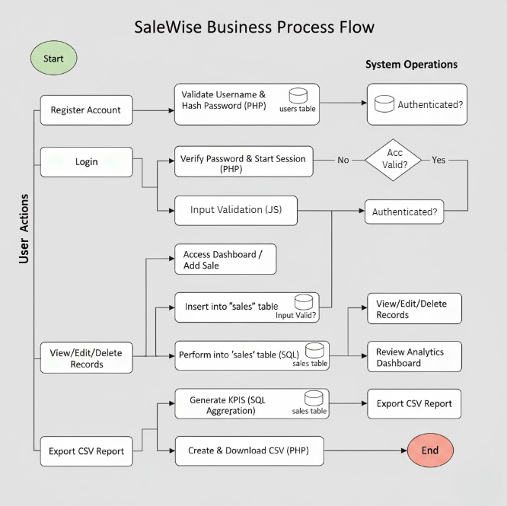

Figure 1: SaleWise Business Process Flow

The operational procedure of SaleWise is built on a very precise workflow with solid verification to make sure data integrity:

1. **Identity Creation**: After a user acquires registration. The system validates the originality of the username and protects the account with the password hash of PHP.
2. **Authentication**: When the user logs in, a secure session is started, and the user is redirected to the dashboard.
3. **Sales Entry**: The user records a transaction. The system examines the input, for example, the RM amount should be positive, before inputting the inputting data in the sales table.
4. **Data Refinement**: The user is able to check the sales history and use the edit function to edit the records if there are any mistakes that are noticed after generating the records.
5. **Analytics Review**: The dashboard is automated and displays key sales metrics that are generated automatically to provide the admin immediate revenue review.
6. **Reporting**: The user can download a CSV report at the end of the section, so they can use it seemingly.

## 2.5 Tools and Technologies Used

The choice of the technology infrastructure was based on solidity, security, and simplicity of local deployment:

|  |  |  |
| --- | --- | --- |
| **Layer** | **Technology** | **Role in SaleWise** |
| Frontend | HTML5 & CSS3 | Offers conceptual framework and flexible interface which is competent of responding to mobile, tablet, and also desktop screens |
| Backend | PHP 8 | Allocate with the logic on the server, processes forms, and safe database relationship with Prepared Statements |
| Database | MySQL | A comparative database management system that will be served to cache user profiles and sales in tabular form |
| Server | Apache (XAMPP) | The hosting environment on the Microsoft and macOS where the PHP and MySQL modules are coordinated and carried out. |

## 2.6 Database Requirements

SaleWise server-side is based on a related database called SaleWise that is secure and regularize the data.

**Users Table**:

* ***id*** (INT, Primary Key): This is the identification of every administrator.
* ***username*** (VARCHAR 50): This keeps a distinctive username that is usable to prevent replicating of accounts.
* ***password*** (VARCHAR 255): A long field that is used in keeping the embedded password of 256-bit hashed password.

**Sales Table**:

* ***id*** (INT, Primary Key): Keeps monitor of every single transaction.
* ***product*** (VARCHAR 100): The illustration name of the product being sold.
* ***category*** (VARCHAR 50): This is used in combined analytics such as "Electronics" or "Beverages".
* ***amount*** (DECIMAL 10,2): When keying financial data, it is suggested to use DECIMAL instead of FLOAT, which will give the accurate value of the items that need two decimals.
* ***created_at*** (TIMESTAMP): This is automatically set to the timestamp when the sale was confirmed to be audited.

## 2.7 Project Timeline

SaleWise was developed in a 17-day structured approach:

1. **Requirement Analysis (20/12/2025 - 22/12/2025)**: Performed a study on the needs of the SMEs and defined the functional needs of the database and the user interface.
2. **System Design (23/12/2025 - 24/12/2025)**: Plan database scheme, framework, and security arrangement.
3. **Core Development (25/12/2025 - 29/12/2025)**: Adjoin the PHP code of the back-end logic and SQL queries and the primary CRUD functionality.
4. **Testing and Improving (30/12/2025 - 01/01/2026)**: Added the better version of the Dashboard functionality, the CSV export utility, and carried out the cross-device responsiveness test.
5. **Final Documentation (02/01/2026 - 03/01/2026)**: Finished the user manual, report, and examined the XAMPP environment to conclude the final presentation.

# 3. System Design

## 3.1 Overall System Architecture

The SaleWise system architecture of a specific program is a chain of subsystems within the program organized hierarchically. It is developed based on a powerful ***Three-Tier Client-Server Architecture***, which is aimed at the separation of concerns, scalability, and easy maintainability. This architectural framework separates the application into three separate layers, and the system can be implemented locally on the XAMPP environment, which packages the required server technologies.

### 3.1.1 Presentation Layer (Client Side)

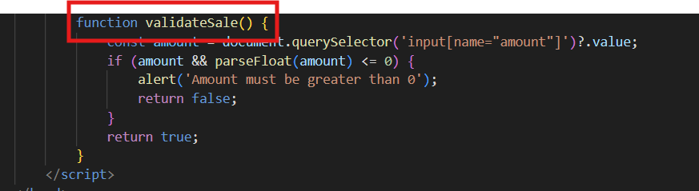

Figure 2: Example of function 'validateSale()' used in 'header.php'

It is the interface with which the user will interact through a web browser like Chrome. The frontend will be built with ***HTML5*** as the structure and ***CSS3*** as a style, considering the principle of responsive design, such as ***Flexbox*** and ***Grid***, to be used to make the site user-friendly on desktops, tablets, and mobile devices. To ensure that clients receive prompt feedback to help minimize unnecessary requests to the server, client-side validation is applied with the help of ***JavaScript***. As an example, the use of the ***validateSale()*** function is in the ***header.php***.

### 3.1.2 Application Layer (Server Side)

PHP 8 with the Apache Web Server has to deal with the core of the business logic. PHP is the processing function of the HTTP requests of the client. As an illustration, it is possible that the user makes a form submission on ***add_sale.php,*** where the PHP script takes the POST data, cleanses it, and connects to the database. This layer handles user sessions as well, and only authenticated users are allowed to access the restricted resources, such as the sales management and dashboard.

### 3.1.3 Data Layer (Database)

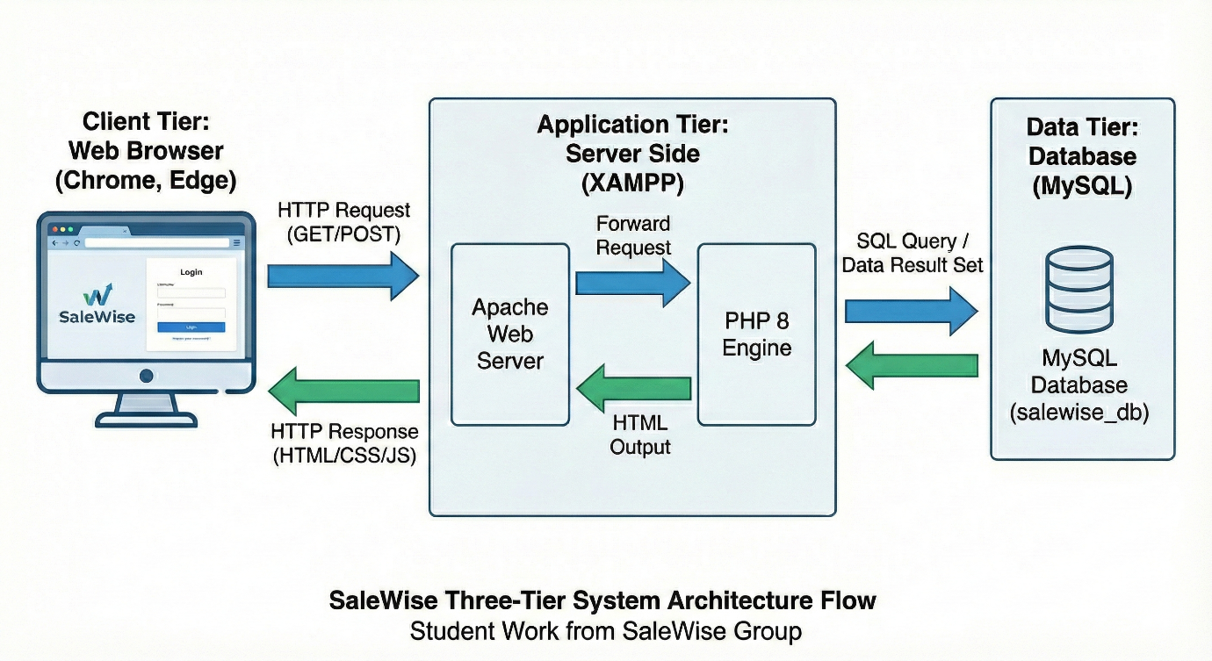

Figure 3: SaleWise’s Three-Tier System Architecture Flow

MySQL takes care of the backend storage. This relational database contains all the data that is persistent, such as user credentials or sales records. This application is linked to this layer through the extension of MySQL in the ***config.php*** that provides a secure connection to the SaleWise database.

The system has a linear interaction pipeline: **Browser → Apache → PHP → MySQL**.

1. **Request**: A user clicks on a link or makes a form request and sends an HTTP request to the Apache server.
2. **Processing**: Apache directs the request to the PHP engine, after which it will run the script. As an example, the logic that could be a check of the passwords, or revenue calculation, of the form on the page called ***login.php***.
3. **Query**: In case of data requirement, PHP sends SQL queries to the MySQL database.
4. **Response**: PHP will create an HTML page that will be filled with the data and returned to the browser to be rendered.

## 3.2 Navigation Structure

The system navigation is in the form of a header-based system that aids in managing and presenting the links dynamically depending on the login level of the user. The navigation system can be summarized as shown below.

### 3.2.1 Header-based Navigation

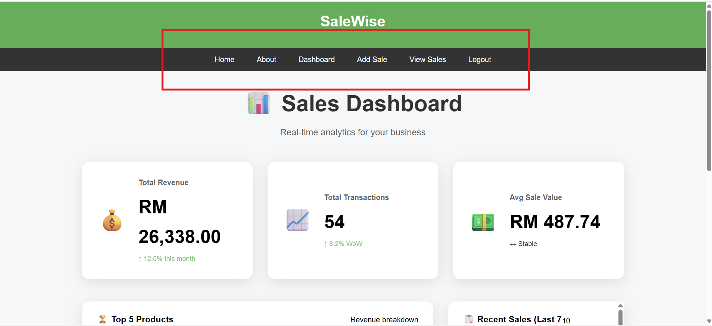

Figure 4: Header-based navigation

The navigation system is context-aware and easy to understand. It is centrally controlled in the file ***header.php***, which is inserted at the top of each page. This gives it a uniform appearance throughout the application.

### 3.2.2 Dynamic State Mechanism

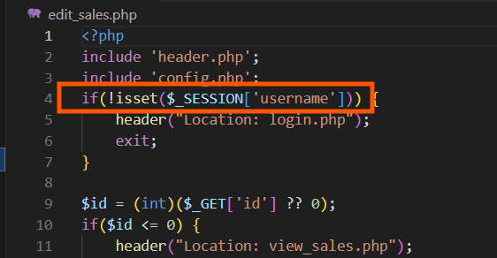

Figure 5: Example of function used in dynamic state mechanism

The navigation bar has a dynamic state, which is maintained by PHP sessions. The system determines whether a user is logged in by checking whether or not a user is logged in by the use of the below statement: ***isset( $SESSION[‘username’])*** and responds by displaying different navigation menu options.

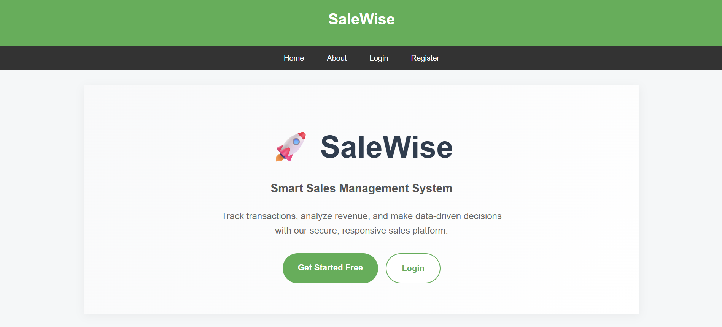

Figure 6: View of guest navigation

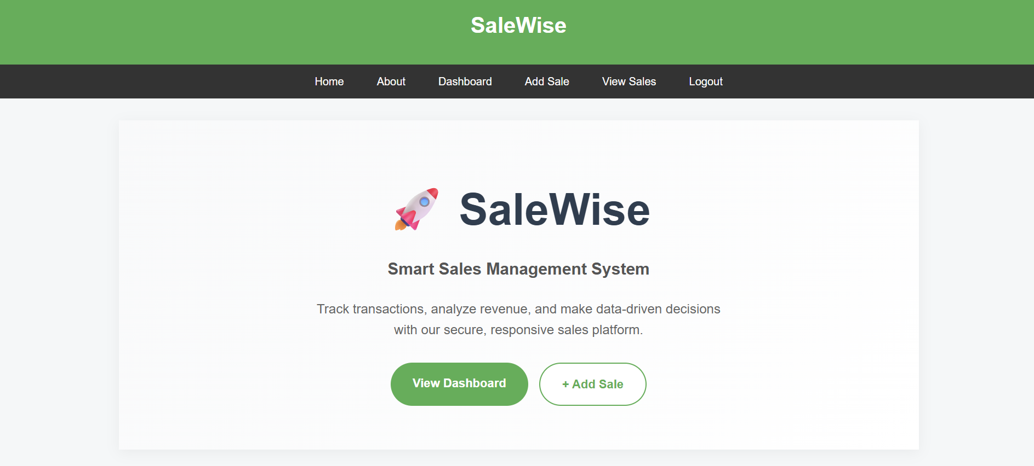

Figure 7: View of authenticated navigation

Concisely, in the guest navigation, a public state, when a user is not logged in, the navigation menu changes to entry points to the system, as indicated in ***figure 5,*** view of the guest navigation. In an authenticated state, the navigation menu changes to operational tools that allow user actions for sales management, as indicated in ***figure 6.***

## 3.3 Wireframes / Mock-ups

### 3.3.1 Home Page

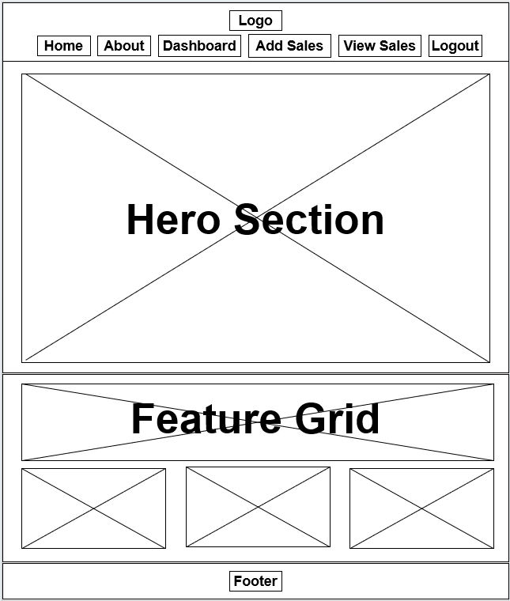

Figure 8: Home Page Wireframe

The homepage will have a simple and contemporary design aimed at conversion and system overview.

* **Header**: Dark-colored navigation bar that has the SaleWise logo and links to Home, About, Login, and Register.
* **Hero Section**: A rocket icon branding centered typography. Has a primary call-to-action (CTA) area that has a View dashboard and Add Sale button.
* **Feature Grid**: A subsection below the fold line ("Why Choose SaleWise?), which uses card-based layouts to point out the main system advantages.
* **Footer**: Copyright and standard system attribution in the middle.

### 3.3.2 Login/register Page



Figure 9: Login/Register page Wireframe

An interface will be created clean and focused so that the user friction is reduced in the course of the onboarding process.

* **Navigation**: Persistently high-level informational links.
* **Authentication Card**: A centered modal-style container.
* **Header**: here should be a big title "Register" to give the context at once.
* **Form Layout**: Vertical stack with labels and input fields of Username and Password.
* **Primary Action**: Full-width "Register" button with a high visibility style.

### 3.3.3 Add Sales Page



Figure 10: Add Sales Page Wireframe

It will be programmed to be easy to enter the data, and the interface is in a normal vertical flow.

* **Contextual Navigation**: The header now contains internal system links (Dashboard, View Sales, Logout) that appear when users have logged in.
* **Section Header**: "Add New Sale" left-aligned title.
* **Input Group**: Centered form card with three core fields:
  + **Product Name**: A text field where exact item can be identified
  + **Category**: Text field with flexible, SME-specific classification
  + **Amount (RM)**: Numerical input field.
* **Submission**: Single "Add Sale →" button.

### 3.3.4 View Sales Page



Figure 11: View Sales Page Wireframe

A layout plan to show with lots of data, which was scannable and administratively controlled.

* **Control Bar**: Horizontal flex container that has a Search bar (with icon) and two main action buttons; one is "Export CSV" and the other one is “+ Add Sale.”
* **Data Grid**: A table format where the following columns are included:
  + **ID**:Bolded unique identifiers.
  + **Product/Category/Amount**: Primary data points.
  + **Date**: Formatted temporal data.
* **Actions**: Inline "Edit" (Green) and "Delete" (Red) buttons for immediate CRUD access.

### 3.3.5 Dashboard Page

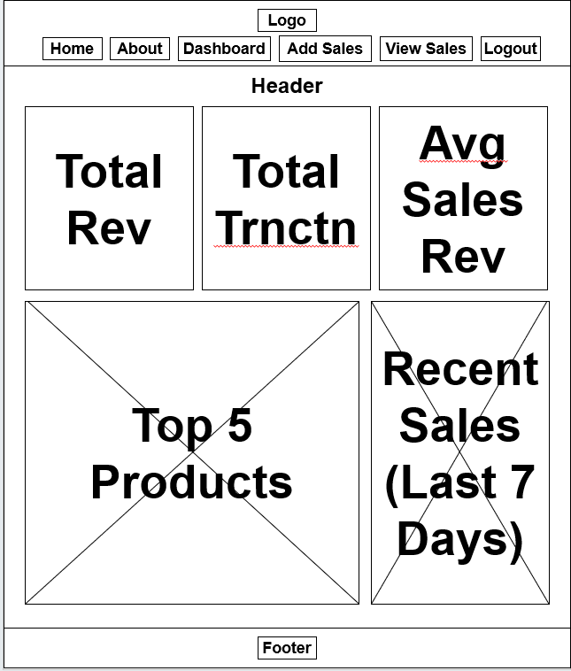

Figure 12: Dashboard Page Wireframe

The interface will has a high-level analytical interface based on card-based "Grid" layout of real-time KPIs.

* **Analytical Cards**: Three primary KPI cards across the top:
  + **Total Revenue**: Big display with trend arrow.
  + **Total Transactions**: This is a number measure that has a Week-over-Week (WoW) change metric.
  + **Avg Sale Value**: Calculated average.
* **Secondary Data Row**: Split layout featuring:
  + **Top 5 Products**: Horizontal bar chart, which represents the revenue per item.
  + **Recent Sales**: A vertical scrollable list of the last 10 transactions.

## 3.4 Database Design (ERD)

### 3.4.1 Architectural Overview

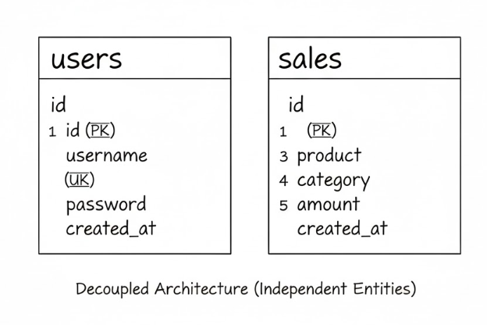

Figure 13: SaleWise ERD

A **Decoupled Database Structure** is employed in the SaleWise system, in which two main independent entities form the database, including ***Users*** and ***Sales***. It is a structurally simple and operationally flexible model, contrary to the traditional strictly-normalized relational database, designed to address the needs of SME environment.

It has two autonomous entities that form the database layer and address two separate functional needs of the system:

* **Users Entity (Authentication Layer)**: This table is the security gateway to the system. It is created to hold special administrative data such as an ***auto-incremented ID (Primary Key)***, a ***unique Username***, and a ***Hashed Password*** to provide effective access control without tampering with the main business data.
* **Sales Entity (Transaction Ledger)**: This table is used as an independent table to hold all the business transactions. It documents the ***Product name***, ***a*** ***dynamic Category***, the ***financial Amount,*** and a ***Timestamp***. The ledger is not dependent on the user table, hence making it portable and capable of being easily exported to external accounting functions.

### 3.4.2 Schema Specifications and Attributes

The tables below outline the physical data model of the application:

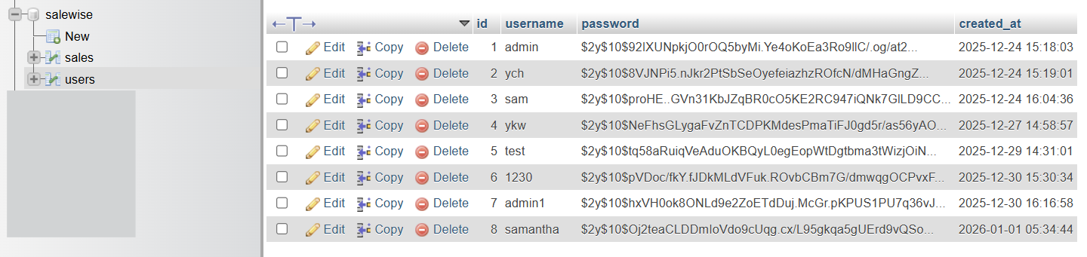

Figure 14: User Storage in MySQL

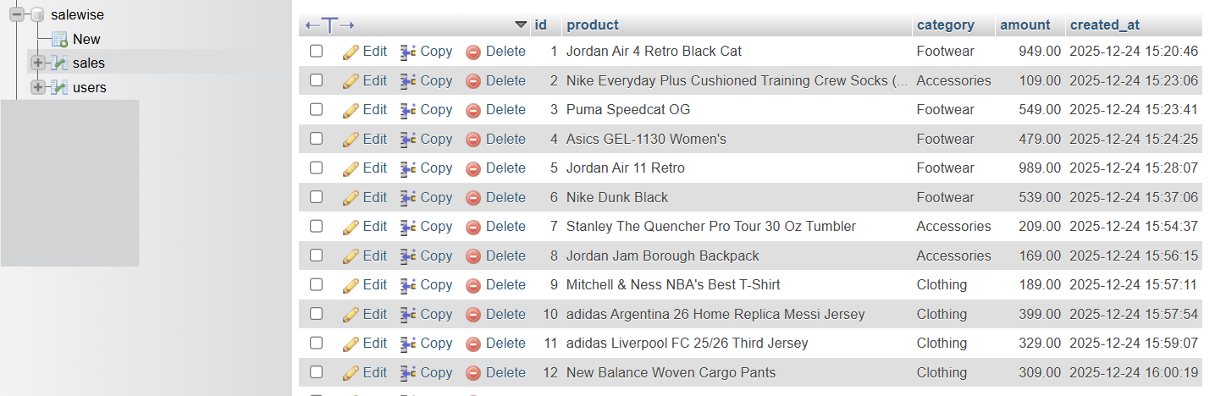

Figure 15: Sales storage in MySQL

|  |  |  |  |  |
| --- | --- | --- | --- | --- |
| **Table** | **Attribute** | **Data Type** | **Constraint** | **Functional Purpose** |
| users | id | INT | PRIMARY KEY | Unique system-generated identifier. |
|  | username | VARCHAR(50) | UNIQUE | Credential for secure user identification. |
|  | password | VARCHAR(255) | NOT NULL | Hashed security token for authentication. |
|  | created_at | TIMESTAMP | DEFAULT | Audit log for account creation. |

|  |  |  |  |  |
| --- | --- | --- | --- | --- |
| **Table** | **Attribute** | **Data Type** | **Constraint** | **Functional Purpose** |
| sales | id | INT | PRIMARY KEY | Unique reference for transaction auditing. |
|  | product | VARCHAR(100) | NOT NULL | Descriptive name of the sold inventory item. |
|  | category | VARCHAR(100) | NOT NULL | Dynamic classification for business versatility. |
|  | amount | DECIMAL(10,2) | NOT NULL | Financial value of the transaction. |
|  | created_at | TIMESTAMP | DEFAULT | Temporal data point for analytics reporting. |

### 3.4.3 Design Rationale: The Decoupled Approach

The strategic design decision to use independent tables was made to satisfy the special needs of a heterogeneous SME user base:

* **Maximum Industry Versatility**: The system is flexible in a “Schema-on-Write” manner by not imposing strict Foreign Key constraints on categories. This enables the owners of businesses in any field to establish their organizational hierarchy without being restricted by the technicalities.
* **Scalability and Portability**: The transaction ledger is independent, which enables a smooth transfer of data. The sales data is a pure, mobile data which can be exported to external business intelligence tools without involving a complicated relational map.
* **Schema Flexibility**: The Category and Product fields are not constrained to as static text entries as in this design. This guarantees that the same system can be used by various types of businesses (e.g., retail and services) without any predefined database list.
* **Analytics Optimization**: Basic Table Joins Dashboard queries (e.g., to get "Total Revenue" or "Top-Selling Items", etc.) can be run directly on the Sales table with significantly faster SQL aggregation, since the system does not require running on expensive table ***JOIN*** operations to get simple transaction data.

## 3.5 Security Design Considerations

The design should be designed with regard to security. The SaleWise application implements security in all tiers of the application to avert the usual web vulnerabilities.

### 3.5.1 Password Hashing

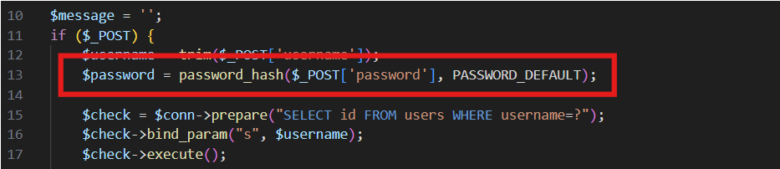

Figure 16: Function used in dynamic state mechanism

In the ***register.php***, the system takes the password and functions ***as password-hash (password, PASSWORD- DEFAULT)*** to generate a secure and randomized hash, and then it is inserted.

### 3.5.2. Verification

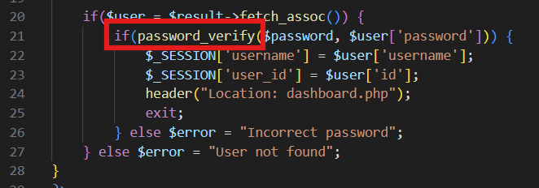

Figure 17: Function used in verifying

In the file ***login.php,*** password verification is done with the help of the input password and the stored hash in the form of ***password_verify***.

### 3.5.3. Prepared Statements (SQL Injection Prevention)

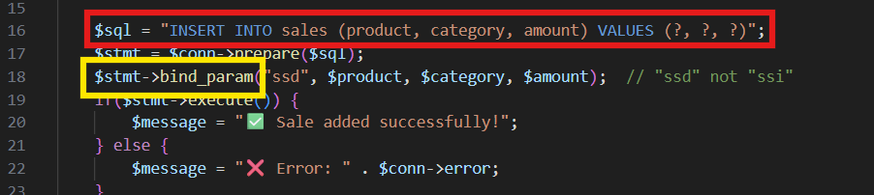

Figure 18: Fuction used in SQL Injection Prevention

All database interactions that refer to user input are all prepared using MYSQLI. In the ***add_sale.php***, the query will be as follows: ***INSERT INTO sale…VALUE(?,?,?)***. Individual values are then bound with the help of the bind-param command, i.e., ***$stmt->bind parameter***. This makes sure that input is being handled like data, neutralizing any malicious SQL commands.

### 3.5.4 Output sanitisation (XSS Protection)

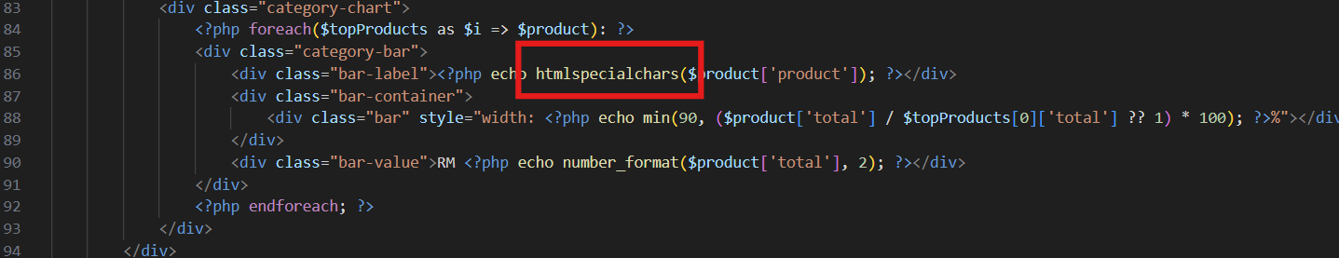

Figure 19: Function used in XSS Protection

To avoid ***Cross-Site Scripting (XSS)***, the system filters all user-generated content and then displays it in the browser. The functions such as ***htmlspecialchars ()*** are applied in the ***view_sales.php*** and in the ***dashboard.php*** to show the names of products or the product categories. This translates the special characters into HTML entities, and the scripts will not run.

### 3.5.5 Authentication by Sessions

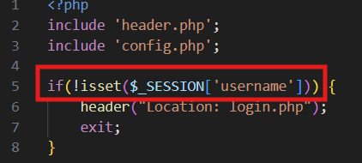

Figure 20: Fuction used in session-based authentication

Access to administrative pages is verified rigorously with the help of PHP sessions. As an example, security checks such as: ***if(!isset($_SESSION[‘username']))*** are made to start with the most important files, such as*:* ***dashboard.php*** and ***add_sales.php***. In case the session variable is not found, the script automatically transfers the user to the login page and stops running.

# 4. Development

## 4.1 System Workflow

SaleWise system is based on a well-organized and progressive order of work, which provides businesses with safe access, correct data processing, and valuable business insights. Every step of the workflow is performed in different specific PHP modules and is linked to the database.

**Step 1: User Registration**

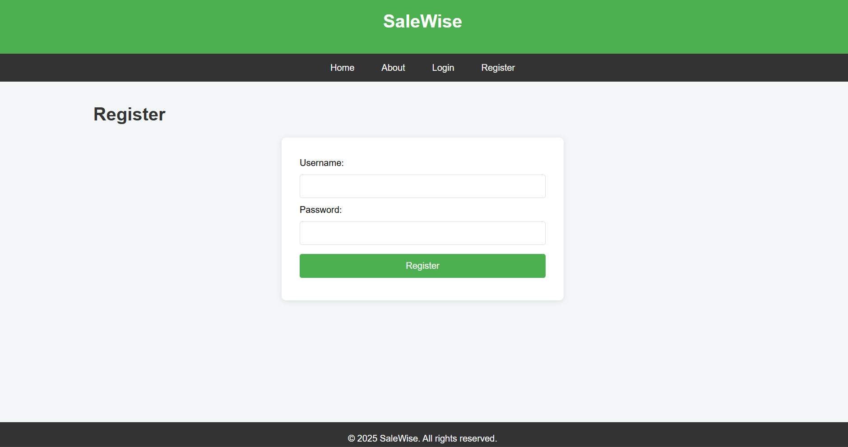

Figure 21: User Registration Form

The workflow starts with the user registration on ***register.php***. New users must fill in their username, e-mail, and password. The password is encrypted by the ***password_hash()*** function of PHP before it is stored. This makes sure that no sensitive credentials are stored in plaintext, which helps in improving system security.

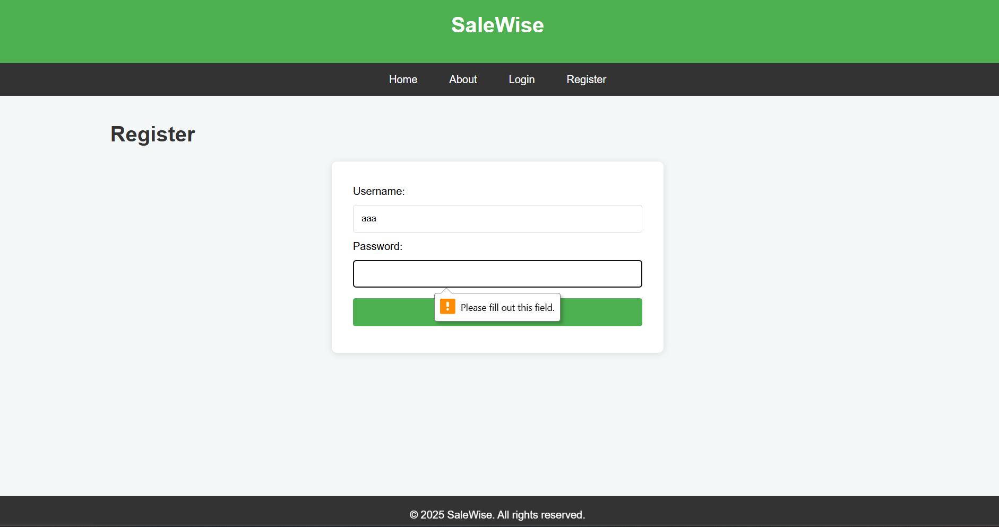

Figure 22: Register Form input validation

Input validation is done to make sure that the fields necessary are not blank and also to make sure that the usernames are not duplicated. After the validation is successful, the user record is inserted into the ***users*** table in the MySQL database with the use of prepared statements.

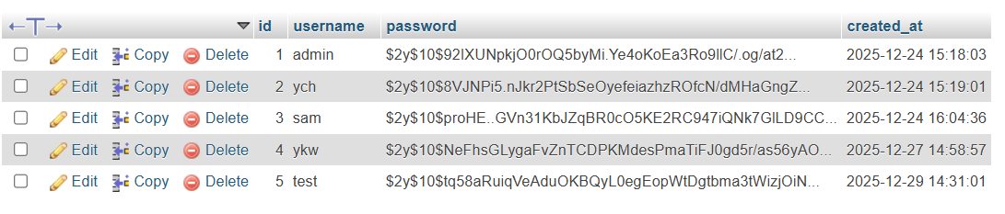

Figure 23: Users Table

**Step 2: Login Authentication**

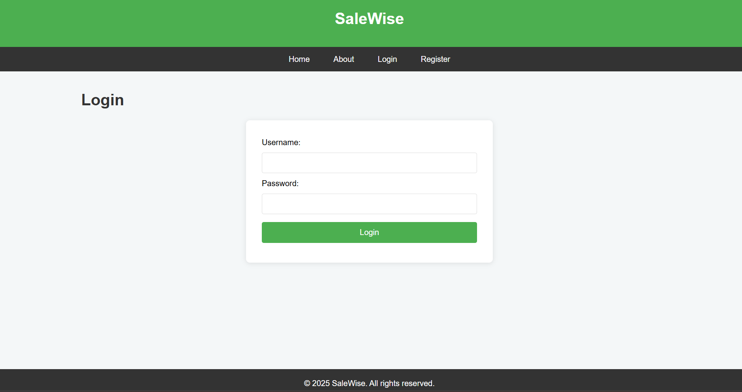

Figure 24: User Login Form

Registered users can log in by means of ***login.php*** whereby credential submitted undergoes comparison with the stored information. The system looks up the hashed password in the database and compares the typed password with the hashed one through the ***password_verify()*** (using password verify).

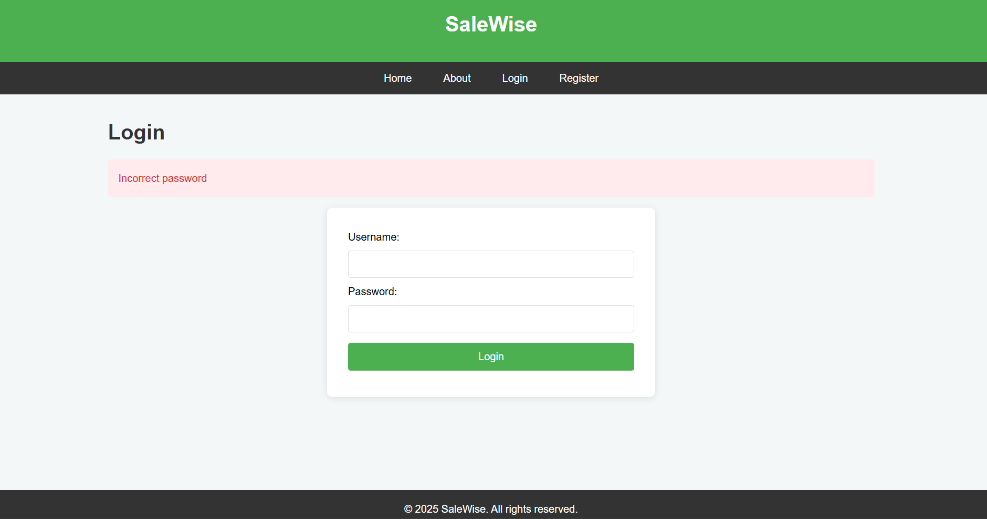

Figure 25: Unsuccessful login

In case of failure by the authentication, an error message will shown. On successful completion of this, the system will advance to session initialization, where access to the controlled resources is granted to the user under controlled access.

**Step 3: Session Creation**

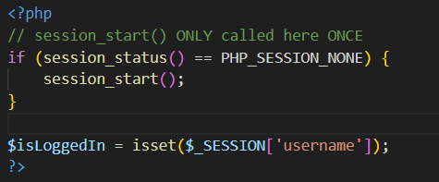

Figure 26: header.php codes

Once logged on successfully, session initiation takes place with ***session_start()***. User identifiers like ***user_id*** and ***username*** are placed in session variables. Session checks are integrated on ***header.php*** that is contained on all restricted pages to provide consistency in enforcing authentication.

Attempts of unauthorized access will automatically redirect the user to the login page, avoiding the direct access to sensitive modules like the dashboard and sales management pages.

**Step 4: Sales Data Entry**

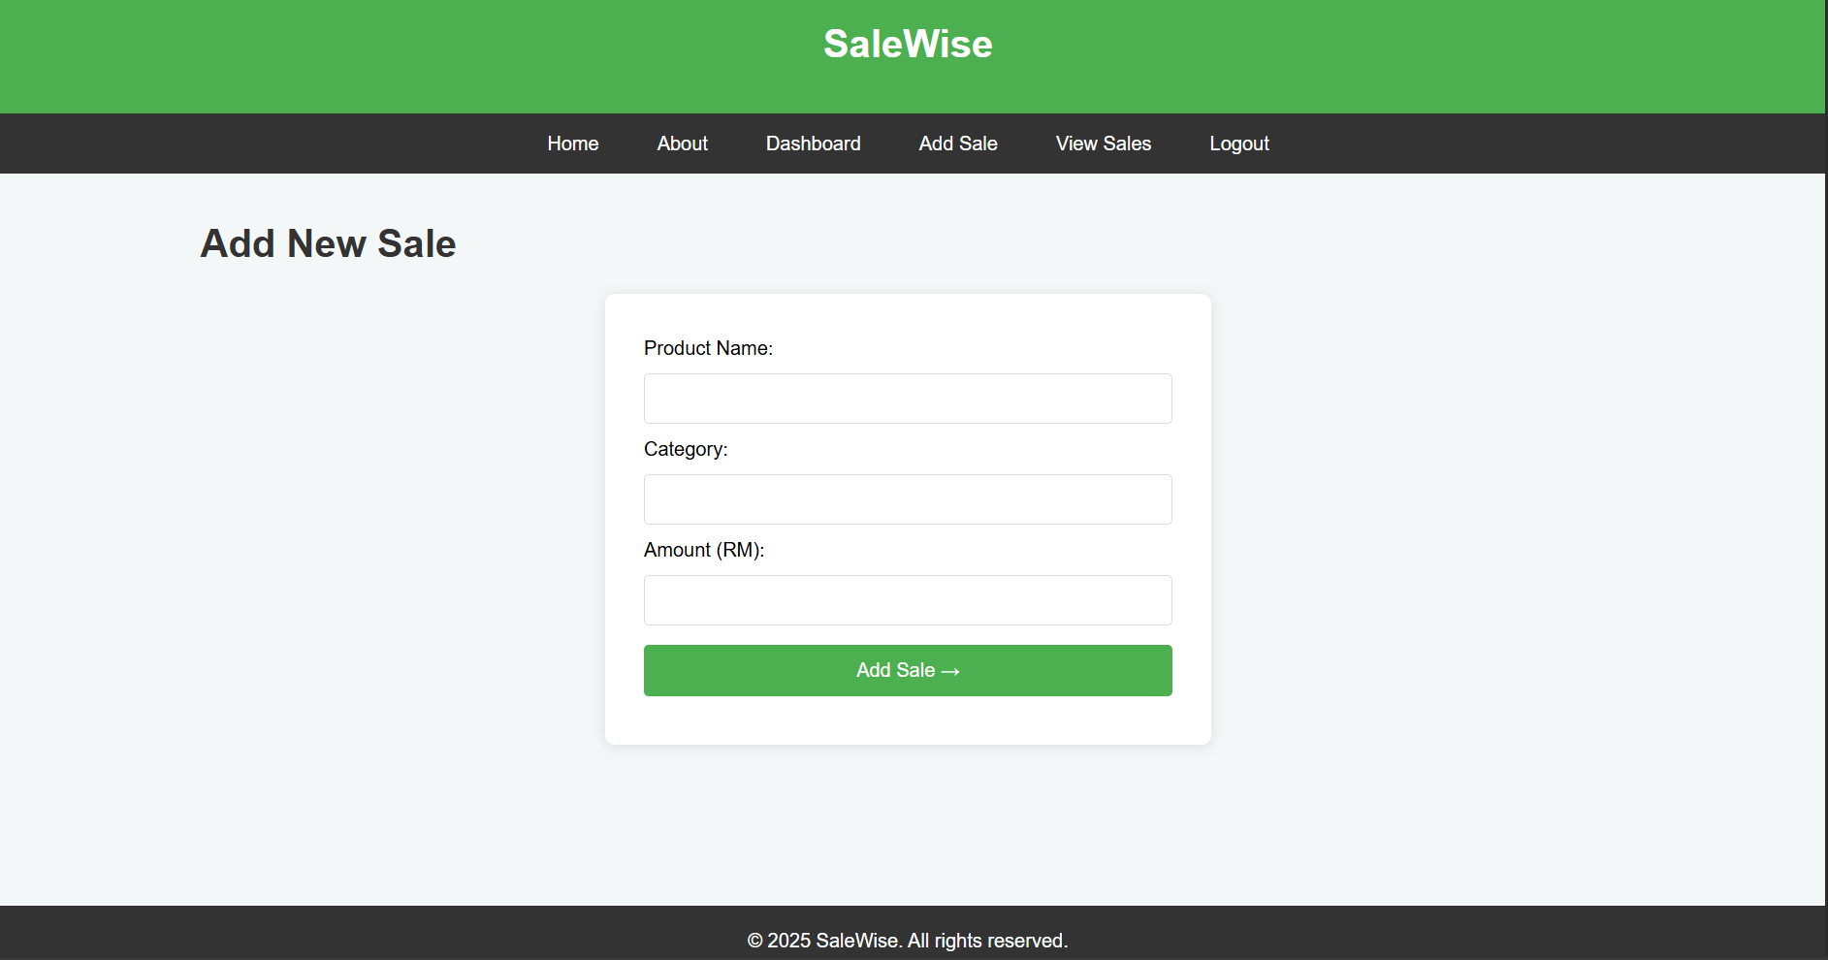

Figure 27: Add Sales Form

The entry of sales is done by means of ***add_sale.php***. Sales data could be entered by an authorized user like the name of the product, its category, the amount of the transaction, and the date. The client and server checks validate the data before it is inserted into the database.

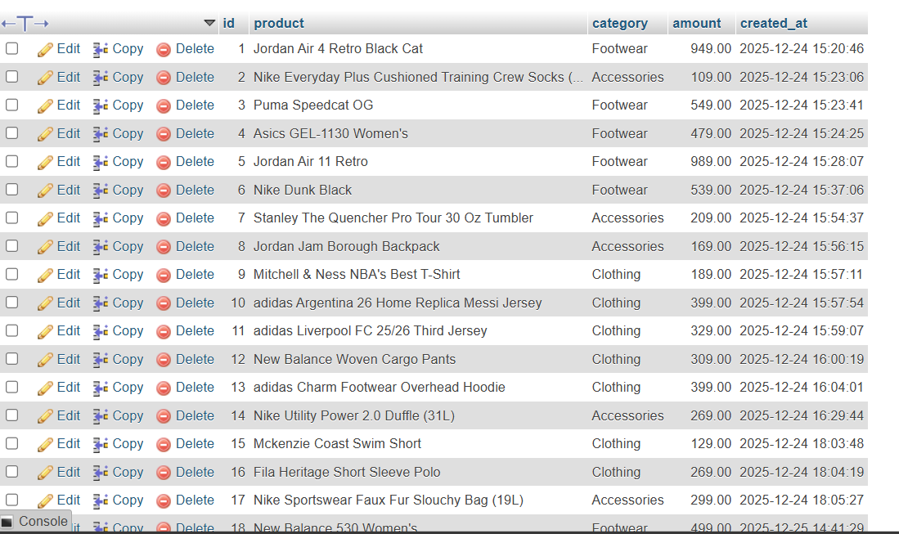

Figure 28: Sales Table

On successful submission, the data will be saved in the ***sales*** table at the ready SQL statement. This will stop SQL injection attacks and ensure the integrity of data.

**Step 5: CRUD Operations**

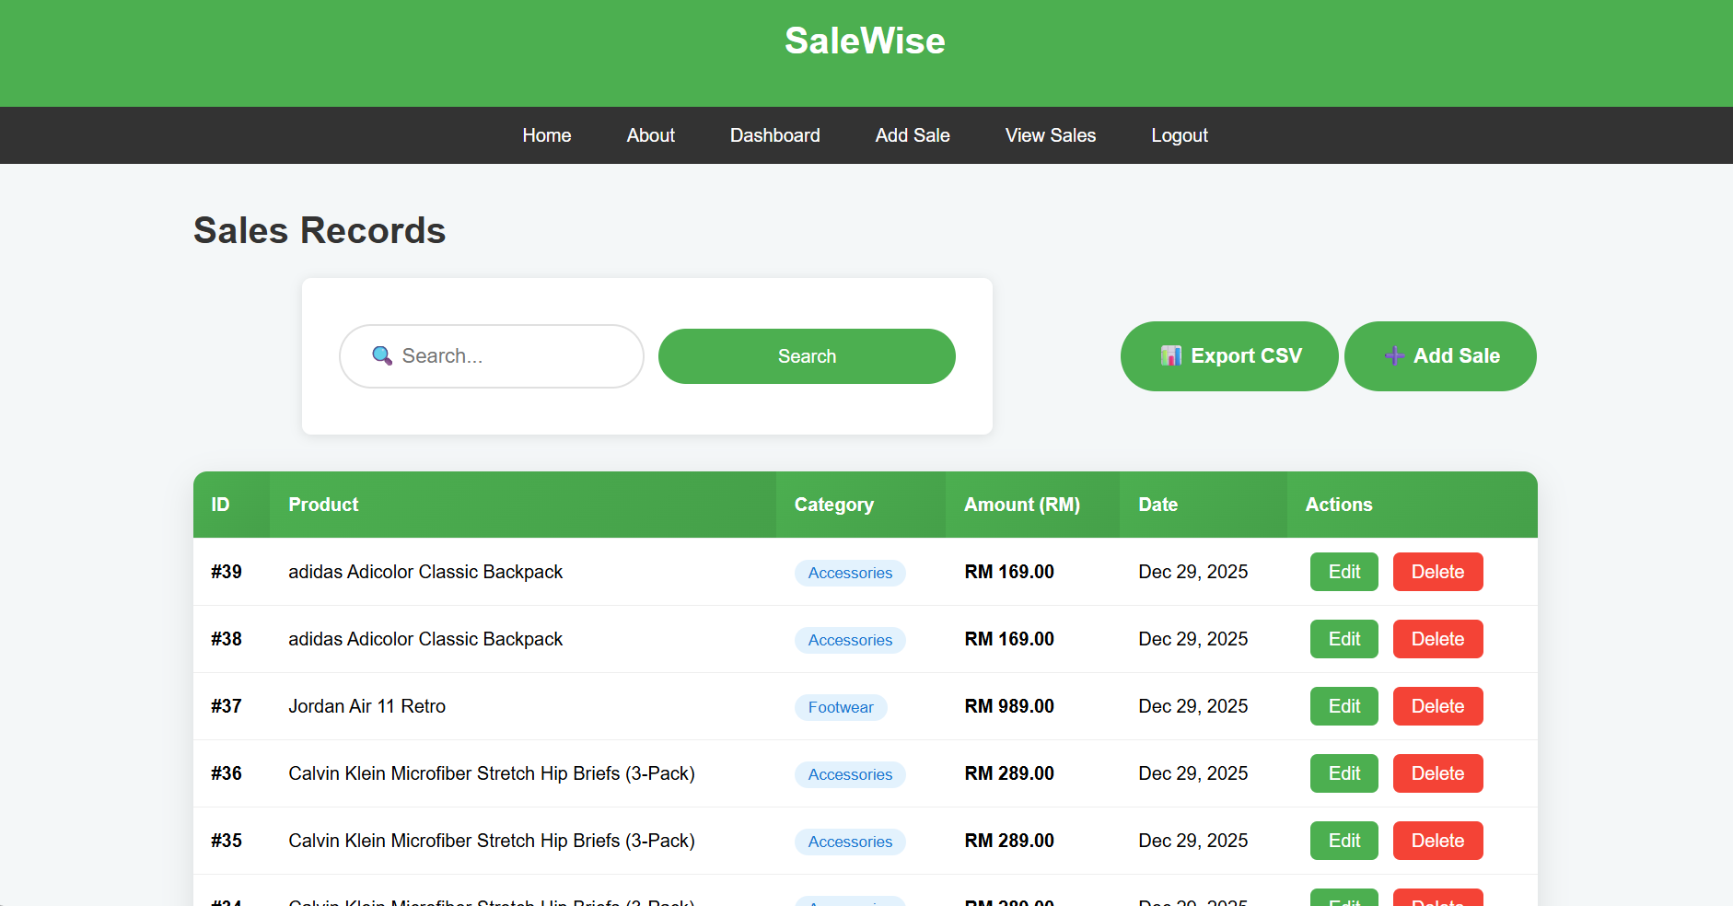

Figure 29: View Sales

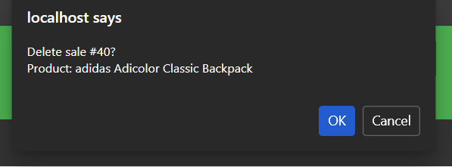

Figure 30: Delete sales record

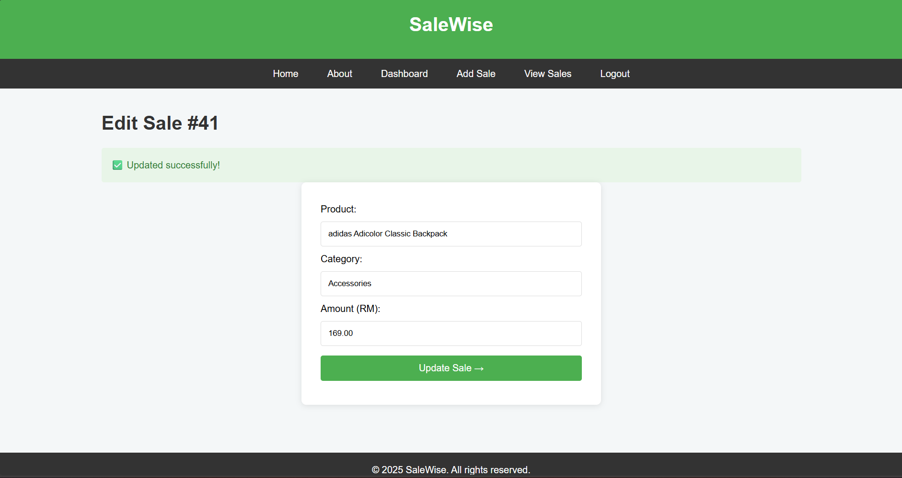

Figure 31: Update sales

SaleWise will support full **Create, Read, Update, and Delete** sales records:

* **Create**: entering new sales.
* **Read**: Reading available sales in tabular form.
* **Update** wrong or old records.
* **Delete**: Getting rid of outdated records.

These functions guarantee that the users are able to achieve complete control over sales data in the business life cycle.

**Step 6: Dashboard Analytics**

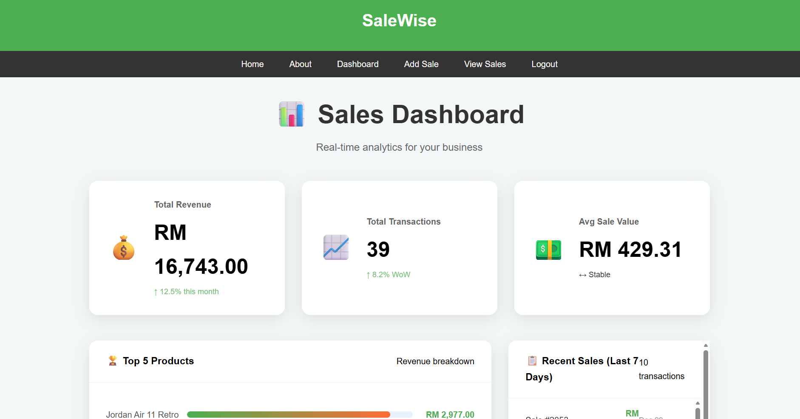

Figure 32: Dashboard

Sales statistics are consolidated in the ***dashboard.php*** module to facilitate real-time business information. Performance indicators are calculated by using SQL aggregation functions like **SUM ()**, **COUNT,** and ***AVG***. The dashboard cards and tables provide users with an opportunity to interpret sales trends and performance measures quickly and present the results visually.

**Step 7: CSV Export**

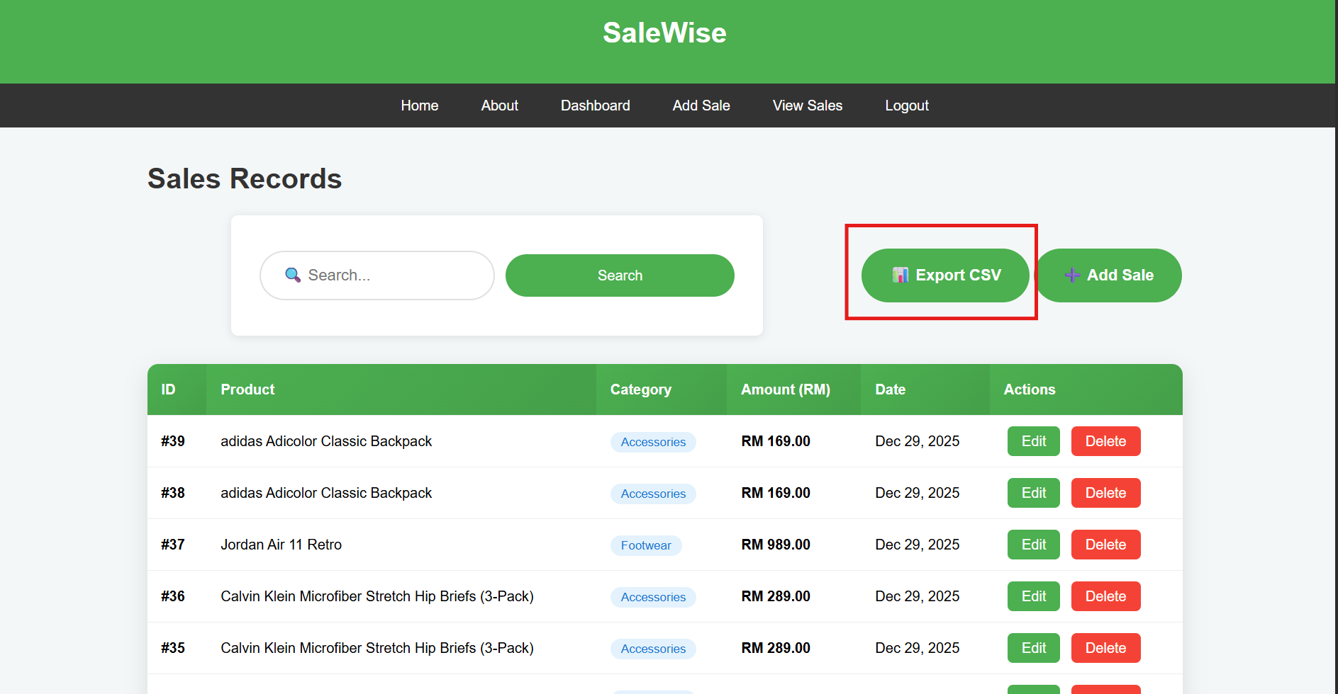

Figure 33: Export CSV File

The ***export sales.php*** module will enable a user to export filtered sales data in the CSV format. This option allows external reporting and additional analysis with the help of the spreadsheet software. The system is dynamic and automatically implements filters and adds a summative revenue overview to the file being exported.

**Step 8: Logout**

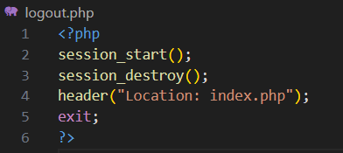

Figure 34: logout.php

Lastly, a user has a chance to leave the system with certain security, with the help of ***logout.php,*** which kills the active session and sends the user to the login page. This will make sure that session data is wiped and avoid shared devices being accessed without authorisation.

## 4.2 Front-End Development

### 4.2.1 HTML Structure

SaleWise uses semantic elements of ***HTML5*** that enhance readability, maintainability, and accessibility.

* ***<header>*** and ***<nav>*** define uniformity in navigation between pages.
* ***<main>*** has page-related information like forms and tables.
* ***<footer>*** shows branding of the system and copyright.

Formal elements are organized with the help of the right type of input (***text***, ***number***, ***password***) to design user interaction and minimise input mistakes. The sale data is displayed with the help of ***<table>***, ***<thead>,*** and ***<tbody>*** elements to provide the structured and readable output. The modularity and consistency of the code can be improved by reusable elements like the ***header.php*** and the ***footer.php***.

### 4.2.2 CSS Styling and Responsiveness

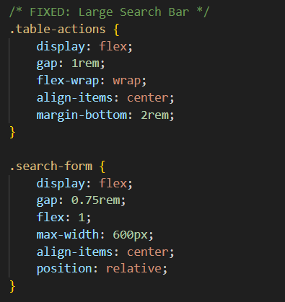

Figure 35: style.css with Flexbox

Styling is also centralized in style.css, and this enhances consistency in designing the system. Forms, tables, and dashboard items are aligned with the help of modern CSS styles like ***Flexbox*** and ***Grid*** layouts.

The important design factors are:

* Monotony of typography and coloring.
* Spacing and alignment are clear to read.
* KPIs hierarchy.

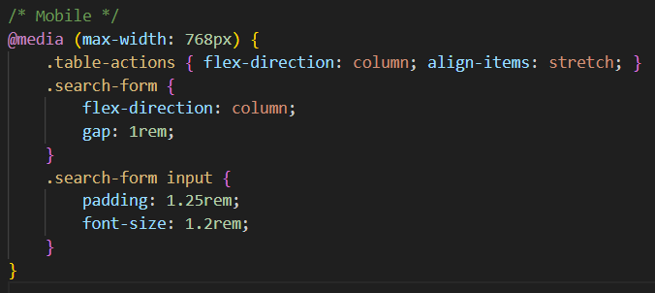

Figure 36: style.css with Media Queries to ensure responsive design

Media queries are used to modify layouts to desktop, tablet, and mobile devices. Tables are also scrollable on small screens, and dashboard cards will dynamically resize themselves so that they can be used, without losing the visibility of the content in the cards.

### 4.2.3 JavaScript Validation

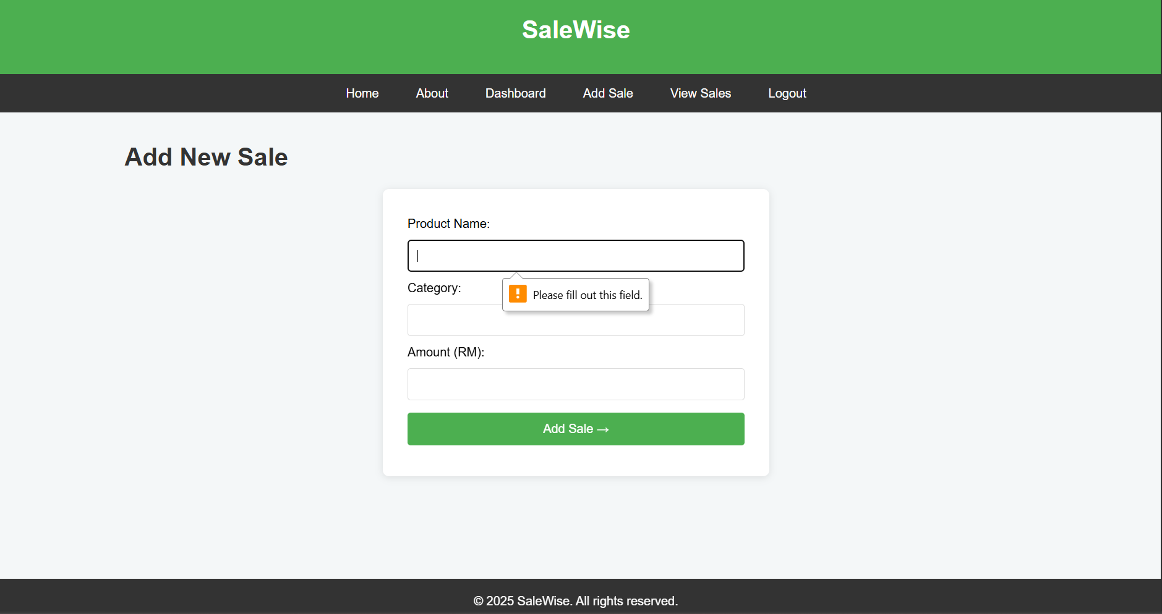

Figure 37: client-side validation for add sales

The use of JavaScript validation is minimal and efficient to provide a better user experience and data precision. Client-side validation will take care of:

* Fields that are sales amounts will accept numeric values only.
* Fields that are mandatory are filled in and submitted.

This validation layer has the effect of minimizing redundant server calls and enhances responsiveness of the system. Nonetheless, every validation is made secure on the server-side to avoid beating around the bush by modifying the browsers.

## 4.3 Back-End Development

### 4.3.1 Authentication Module

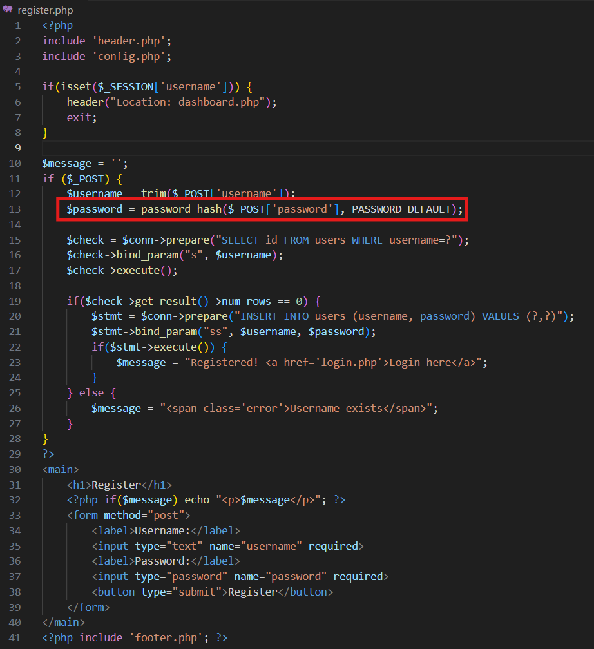

Figure 38: register.php codes

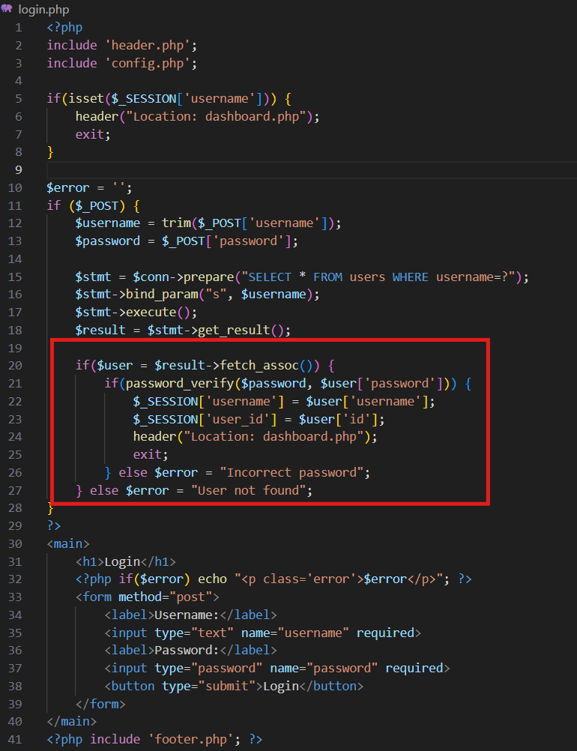

Figure 39: login.php codes

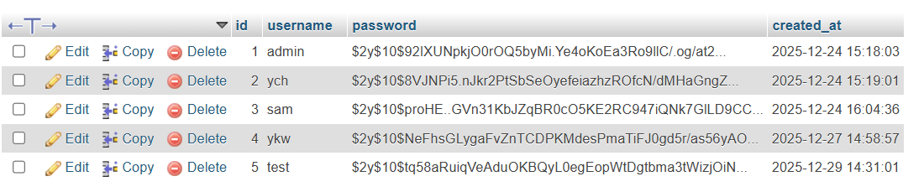

Figure 40: Password encrypted

Files involved:

* ***login.php***
* ***register.php***
* ***logout.php***

The authentication module provides a secure user access by industry-standard practices. Registration is done with a password that is encrypted with ***password_hash()*** and verification is done with **password_verify()**.

Sessions are centrally controlled, and they enable the use of persistent login states in protecting against restricted pages. The process of logging out expressly removes the data of the session in order to avoid reuse.

### 4.3.2 Sales Management (CRUD)

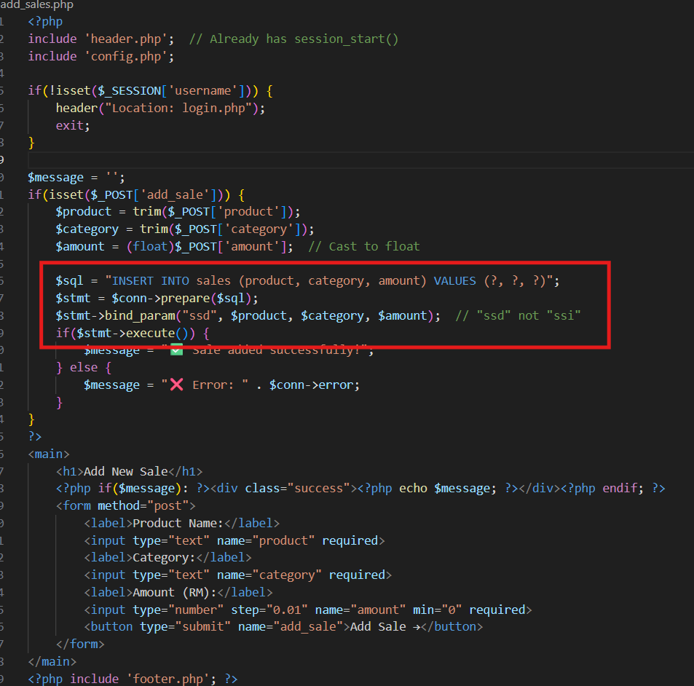

Figure 41: add_sales.php codes to create a sales record

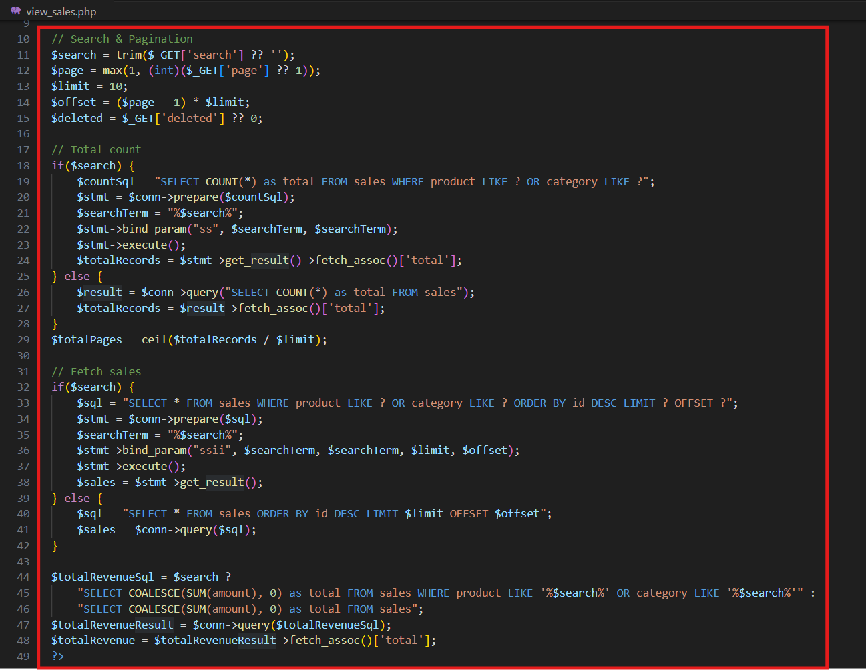

Figure 42: view_sales.php to read sales records

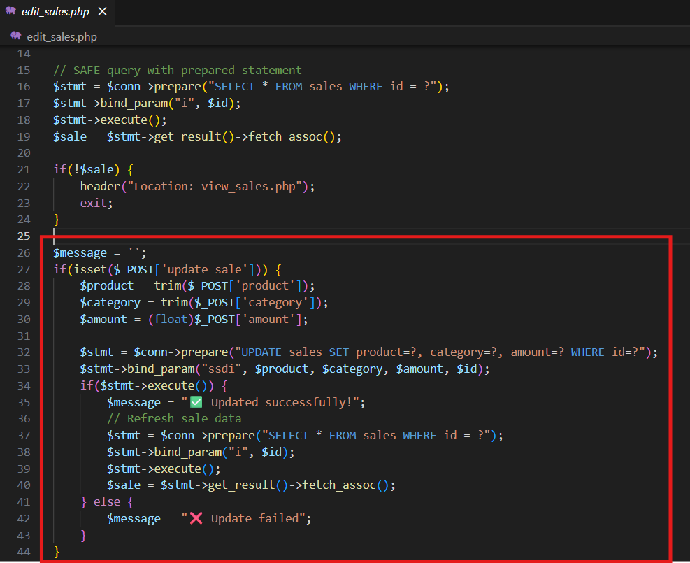

Figure 43: edit_sales.php for Update Function

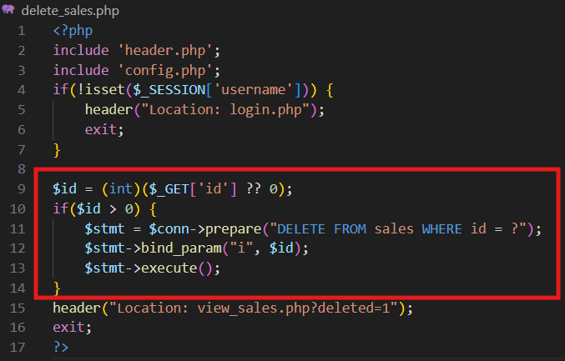

Figure 44: delete_sales.php for the Delete function

Files involved:

* ***add_sales.php***
* ***view_sales.php***
* ***edit_sales.php***
* ***delete_sales.php***

All CRUD operations are executed using prepared statements to avoid SQL injection attacks. Data validation is used to ensure accuracy in the data on transactions, and output is sanitized with ***htmlspecialchars()*** to reduce the risks of ***XSS***. Deletion is confirmed by the use of confirmation dialogs, which minimizes chances of loss of data by accident.

### 4.3.3 Dashboard Analytics

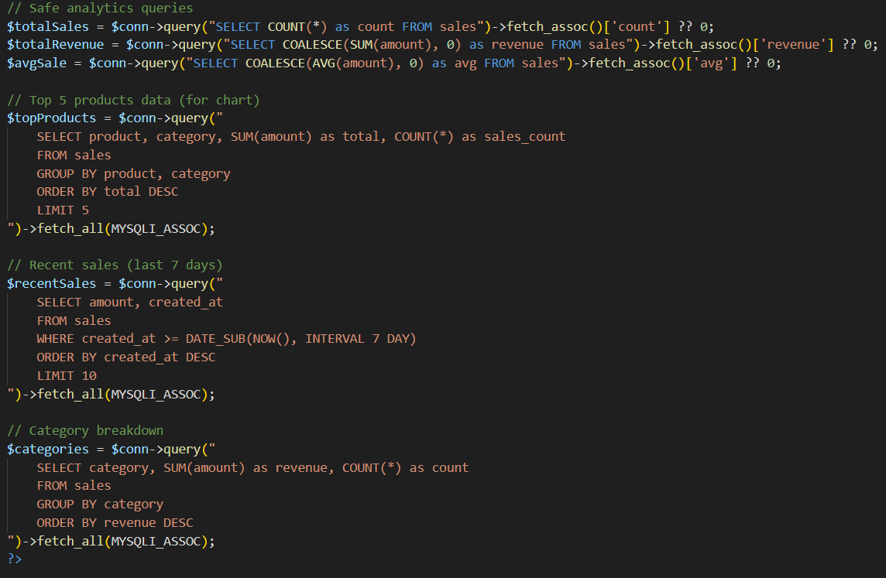

Figure 45: dashboard.php codes using SUM(), COUNT(), GROUP BY

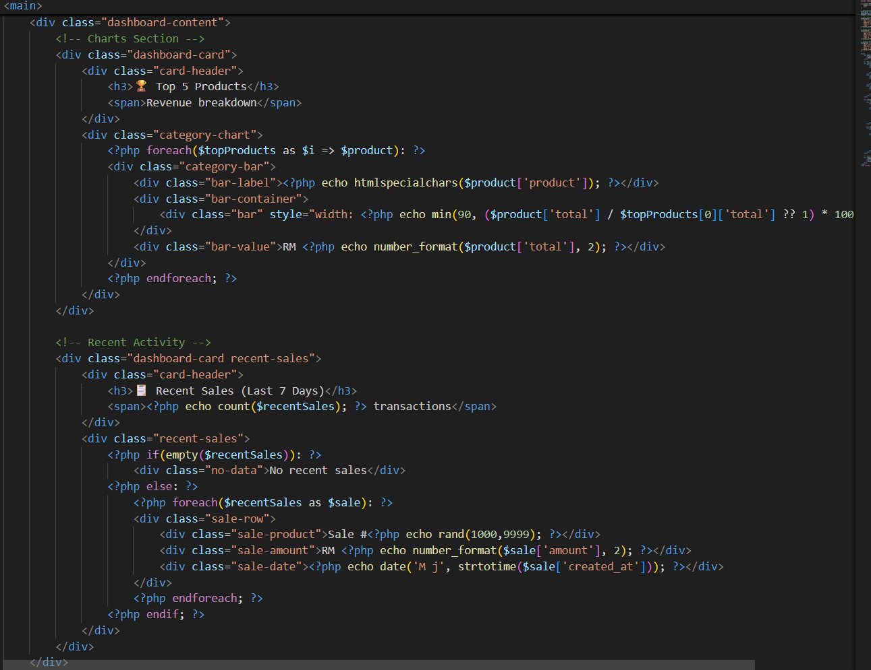

Figure 46: dashboard.php codes for Top Selling Products and Recent Transactions

File involved:

* ***dashboard.php***

The analytical core of SaleWise is the dashboard. SQL queries will take advantage of sales information to calculate:

* **Total Revenue** using ***SUM(amount)***
* **Count of the Total Transactions** with the help of ***COUNT(id)***
* **Mean value of Sale** using ***AVG(amount)***
* **Best-selling Products** with grouped and ordered queries.
* **Recent sales** in the form of date sorting.

The results are displayed in real-time, which gives its users current information whenever the dashboard is opened.

### 4.3.4 Export Functionality

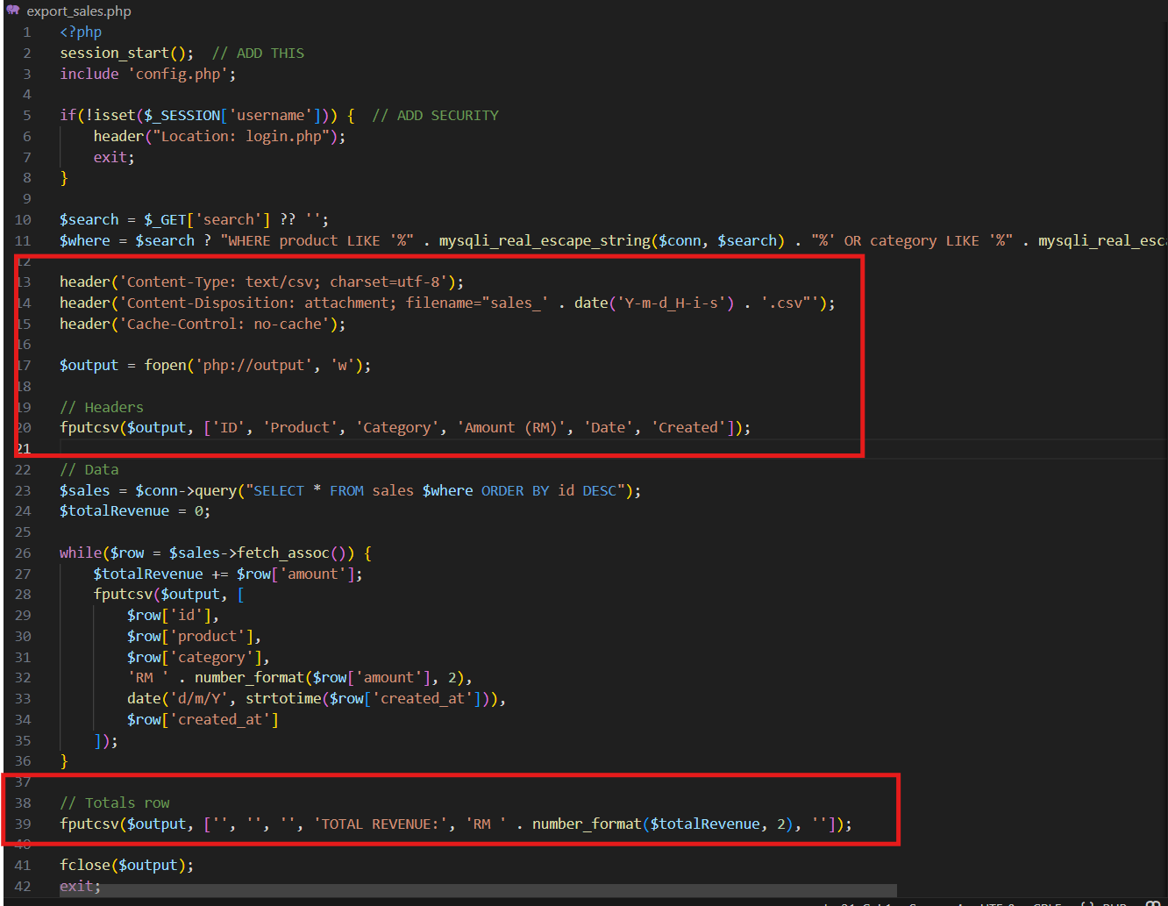

Figure 47: export_sales.php codes for exporting csv file with a header and appending total sales

File involved:

* ***export_sales.php***

The export module produces CSV files that have the right HTTP headers to make sure they are formatted properly. The filtered data is read according to user-specified parameters, and a sum of revenues row is added at the file's end. This feature makes the system more useful in terms of reporting, auditing, and decision-making.

## 4.4 Key Code Snippets (Explained)

|  |  |  |
| --- | --- | --- |
| **Feature** | **Code Evidence** | **Snippets** |
| SQL Injection Prevention | prepare() | Prepared SQL statements to prevent SQL injection |
| Password Security | password_hash() | Password hashing and verification for secure authentication |
| Access Control | $_SESSION | Session checks to enforce access control |
| Analytics | SUM(), COUNT(), AVG() | Aggregate SQL queries for analytical computations |

# 5. Testing and User Acceptance

## 5.1 Test Plan

To ensure the reliability and functionality of SaleWise, a comprehensive test plan was executed, focusing on the core modules of the system. The testing strategy primarily utilized Black Box Testing, where the internal code structure was not the focus, but rather the input-output behaviour of the application. The objective was to verify that the system meets the functional requirements defined in our requirement analysis.

|  |  |  |  |  |  |
| --- | --- | --- | --- | --- | --- |
| **Feature** | **Test Case Scenario** | **Test Type** | **Expected Outcome** | **Actual Result** | **Status** |
| User Authentication | User attempts to login with valid credentials | Functional | System redirects to ‘dashboard.php’ and starts a session | Redirected successfully with session active | PASS |
| Security Validation | User attempts to login with an incorrect password | Functional | System stays on ‘login.php’ and displays “Incorrect password” error | Error message displayed correctly | PASS |
| Add Sale Validation | User submits the “Add Sale” form with a negative amount (example RM-50) | Functional | JavaScript alert and prevents submissions | HTML ‘min=0’ attribute prevented submission | PASS |
| Add Sale Success | User enters valid product, category, and amount details | Functional | Data is inserted into ‘sales’ table, and success message appears | Record added to Database with “sale added successfully!” shown | PASS |
| Edit Record | User updates the amount of an existing sale | Functional | The database record updates and ‘view_sales.php’ reflects the new value | Value updated in table immediately | PASS |
| Delete Record | User clicks “Delete” on sales row | Functional | A confirmation dialog appears with “OK”, then the row is removed | Row deleted from Database and table view | PASS |
| Dashboard Analytics | User adds a new sale of RM100 | Functional | Total Revenue card increases by RM100 immediately | Dashboard KPIs updated dynamically | PASS |
| Export Functionality | User clicks “Export CSV” | Functional | A ‘.csv’ file is downloaded containing all sales records | File downloaded with correct headers and content | PASS |

## 5.2 CRUD Evidence

The core functionality of SaleWise is its ability to manage sales data through **Create, Read, Update, and Delete (CRUD)** operations. The following evidence demonstrates the successful implementation of these features using the ‘sale’ database table.

### 5.2.1 Create (Add Sale)

This module allows users to record new transactions.

|  |  |
| --- | --- |
| **Action** | The user navigates to ***‘add_sales.php’*** and fills in the ***“Product Name”,”Category”, and “Amount”.*** |
| **Result** | Upon clocking ***“Add Sale”***, the system uses a prepared SQL statement, which the function of ***‘INSERT INTO sale’*** to store the data safely. |

### 5.2.2 Read (View Sales)

This page serves as the main ledger.

|  |  |
| --- | --- |
| **Action** | The user navigates to ***‘view_sales.php’*** |
| **Result** | The system fetches all records from the MySQL database and displays them in a structured HTML table. The Total Revenue is calculated and displayed at the bottom of the table. |

### 5.2.3 Update (Edit Sales)

This feature allows for the correction of data entry errors.

|  |  |
| --- | --- |
| **Action** | The user clicks the ***‘Edit’*** button next to a specific record. The system redirects to ***‘edit_sales.php?id=x’*** and pre-fills the form with the current data. |
| **Result** | After modifying the ***“Amount”*** or ***“Product Name”*** and saving, the record is updated in the database without creating a duplicate entry. |

### 5.2.4 Delete (Remove Sales)

This feature allows for the correction of data entry errors.

|  |  |
| --- | --- |
| **Action** | The user clicks the red ***“Delete”*** button |
| **Result** | JavaScript confirmation prompt ***‘confirm (‘Delete sale #...?’)’*** acts as a safety mechanism. Upon confirmation, ***‘delete_sales.php’*** executes ***“DELETE”*** query and the row disappears from the view. |

## 5.3 Responsiveness Testing

To ensure the system is accessible on various devices, SaleWise was built using ***CSS Flexbox*** and ***Media Queries***. Testing was conducted using Chrome Developer Tools’ device toolbar to simulate different screen sizes.

### 5.3.1 Desktop View (width >1034px)

Ensure that the layout looks good on larger screens and the navigation bar remains intact, and all elements are aligned properly.

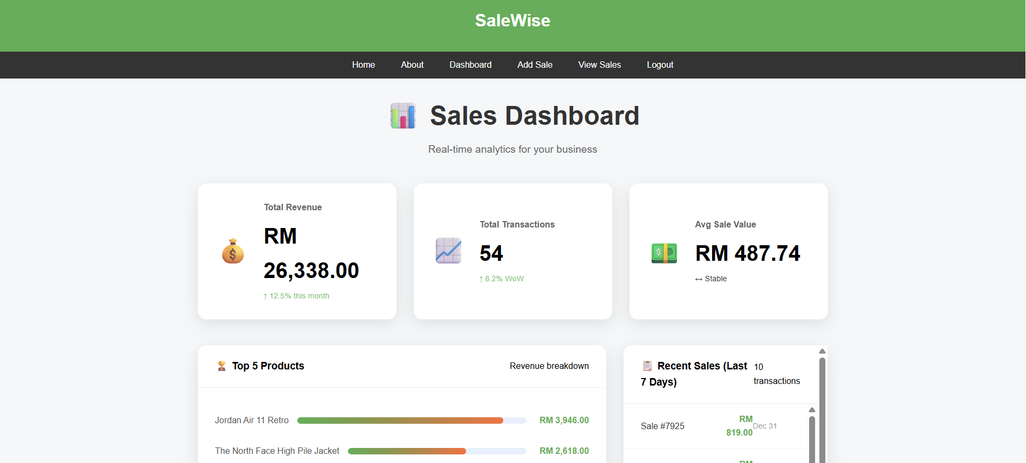

Figure 48: Desktop View

### 5.3.2 Mobile View (width <480px)

The UI design adapts well to mobile devices, with clickable buttons and optimized form fields. Check for issues with responsiveness, like text being cut off or elements not resizing correctly.

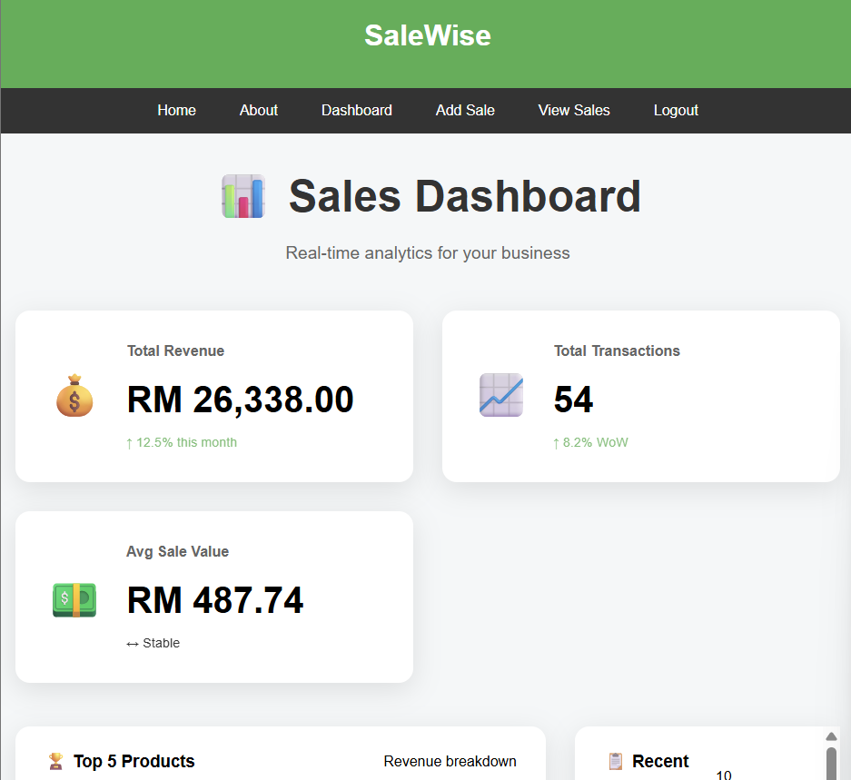

Figure 49: Mobile View

# 6. Implementation & User Guide

## 6.1 Installation Guide

**Step 1: Install XAMPP or WAMP**

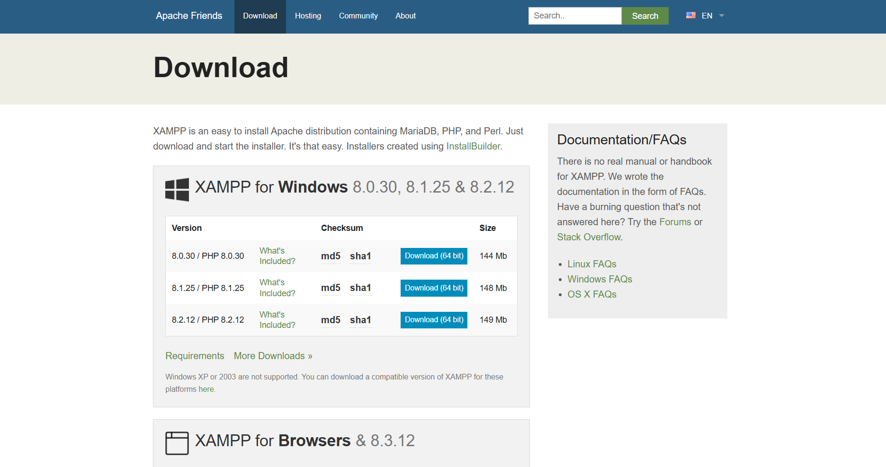

Figure 50: Download XAMPP in browser

XAMPP or WAMP is the first step that involves the download and installation of the necessary Apache web server and MySQL database services. XAMPP is chosen because of its cross-platform use and simplicity in configuration.

**Step 2: Apache and MySQL Services start**

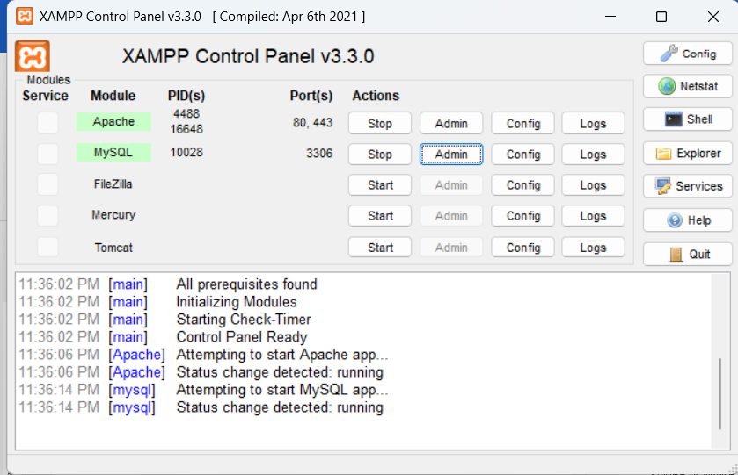

Figure 51: Start Apache and MySQL using XAMPP Control Panel

After its installation, the XAMPP/WAMP control panel must be opened and both MySQL and Apache services started. A green status light or Running label is a sign that it will start successfully. These services are needed to execute PHP scripts as well as database operations.

**Step 3: Import the Database (salewise.sql / salewise_db.sql)**

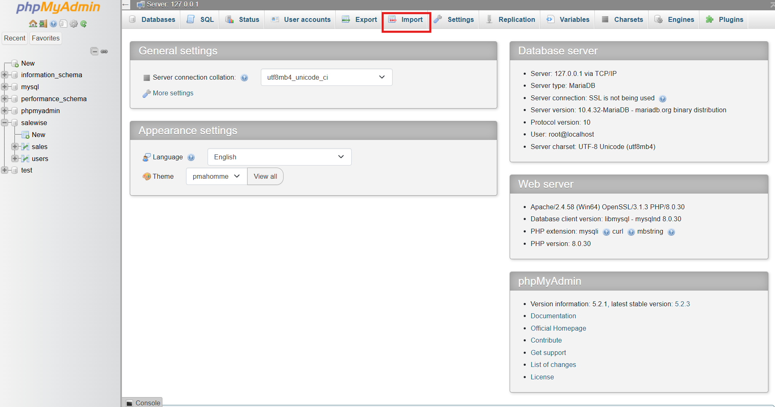

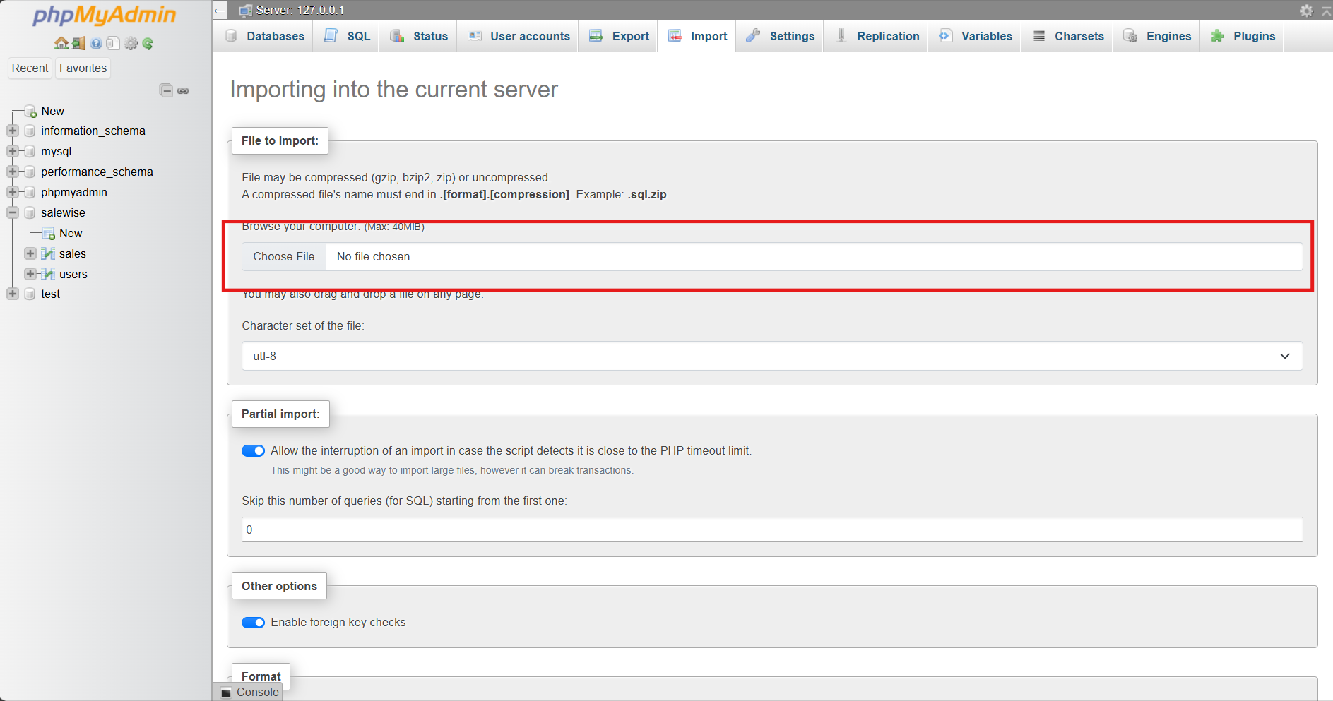

Figure 52: Option 1 (with data) Import all the readily available data by importing the salewise.sql in PhpMyAdmin

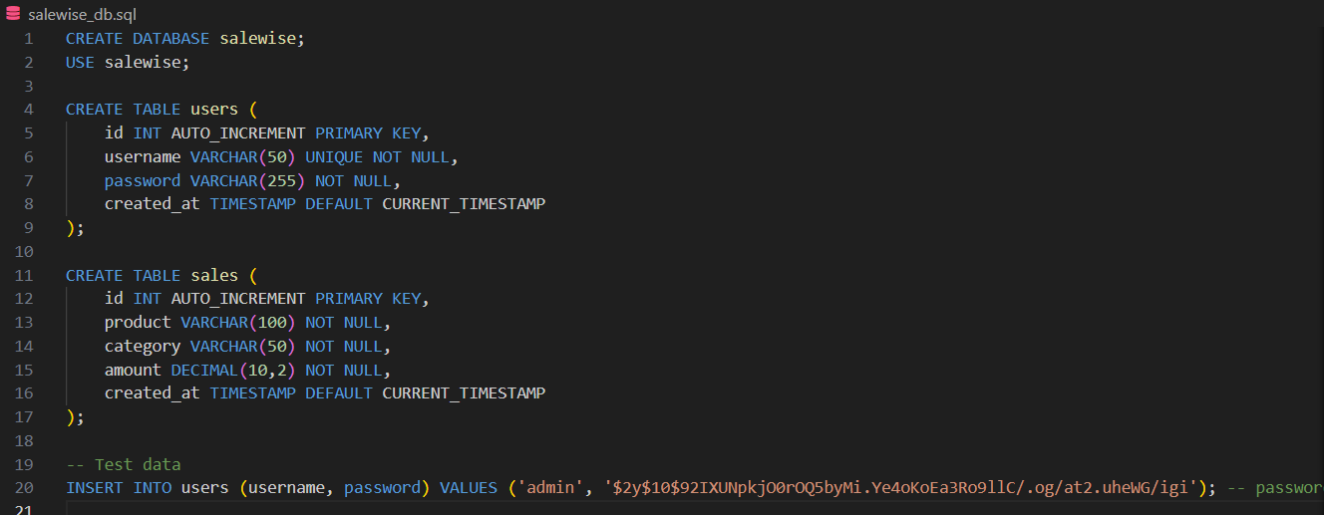

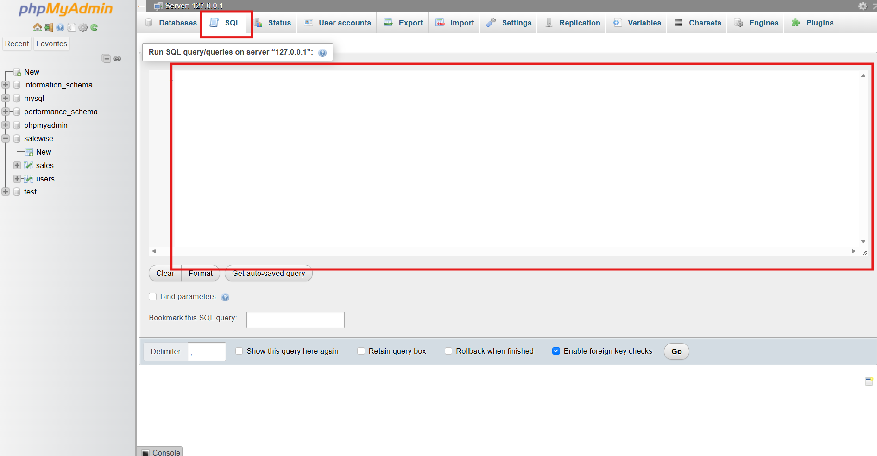

Figure 53: Option 2 (clean database without data) Copy the code in salewise_db.sql (in the SaleWise project folder) and paste it into PhpMyAdmin SQL to create db automatically

Users can initiate the SaleWise database through the importation of the ***salewise.sql*** file or copy the code from the ***salewise_db.sql*** file in the SaleWise folder and paste it into the SQL of PhpMyAdmin. This can be done by connecting to phpMyAdmin on localhost using a web browser, i.e., ***http://localhost/phpmyadmin***. After that, the SaleWise database will be created, using either of the above two methods. It will generate the tables (users and sales) required with their attributes automatically.

**Step 4: Copy the Project Folder**

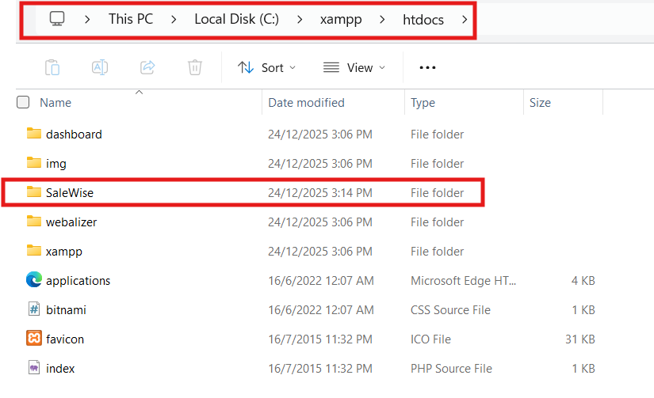

Figure 54: Locate the SaleWise Folder in this Path

Next, copy the entire SaleWise project folder and paste it into the ***htdocs*** (in case of XAMPP) directory or the ***www*** directory (in case of WAMP). This is to enable the Apache server to identify and deliver the application files.

**Step 5: Log into the System using Browser**

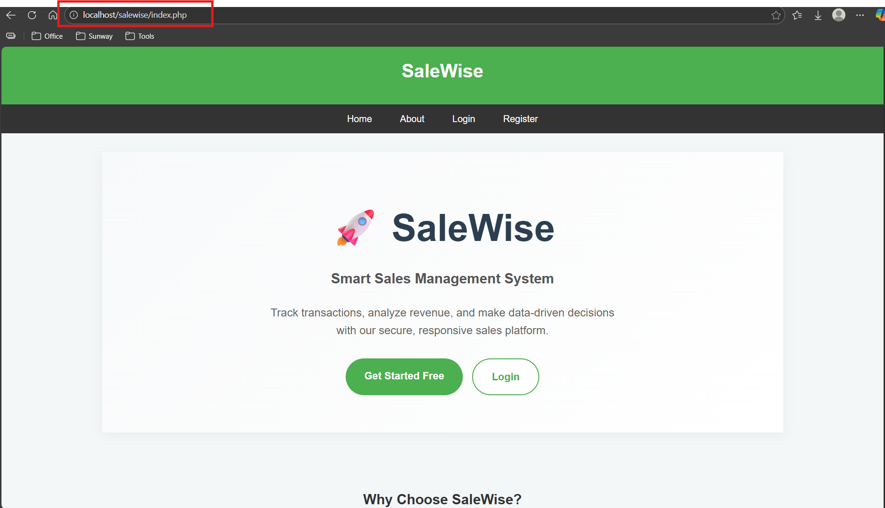

Figure 55: Visit the website using the address in browser

Lastly, the system is available in the form of entering the following web address in a web browser, that is, ***http://localhost/salewise/***. Assuming it is successful, the user will be presented with a login page of SaleWise system that means that the system is ready to be used.

## 6.2 User Guide

**Step 1: User Registration**



Figure 56: User Registration Form

The registration page requires first-time users to create an account. The user must register his/her username, email address, and password. The password is hashed safely before being saved in the database when it is submitted. Registering successfully takes the user to the login page.

**Step 2: User Login**



Figure 57: User Login Form

Registered users are allowed to log in with their username and password. The system checks if the credentials match with the hashed password that is stored. After successful authentication, a session is established, and the user is redirected to the dashboard. Strict pages cannot be accessed by an unauthorized user.

**Step 3: Adding Sales Records**



Figure 58: Add Sales Form

The Add Sales page allows for the addition of new sales transactions can be added. Product name, category, and transaction amount with the date are the details that are needed in the form. Basic validation makes sure that all the necessary fields are filled and the amount typed can be considered as valid. When it is submitted, it is then stored in the database and can be viewed and analyzed immediately.

**Step 4: Viewing, Editing, and Deleting Records**



Figure 59: View Sales



Figure 60: Delete sales record



Figure 61: Update sales

The View Sales page presents all the transactions that were made in a structured table. The users are able to compare their sales and provide updates or deletion functions. Through editing, the user will be able to edit or modify current records, whereas deletion permanently removes records upon confirmation. These functions make the system complete CRUD.

**Step 5: Using the Dashboard**



Figure 62: Dashboard

The dashboard gives a summary of the sales performance in terms of key performance indicators (KPIs). The users are able to see the total revenue, total number of transactions, average sale value, and the best-selling products. Recent sales are also listed with a view to giving live information about the business performance. This aspect would allow users to make wise decisions based on consolidated sales reports.

**Step 6: Exporting Sales Data**



Figure 63: Export CSV File

The SaleWise enables an individual to export sales data to a CSV file using the export feature. The file that is being sent out contains all the pertinent sales data and a sum of total revenue. This option facilitates the external analysis and reporting with the help of the spreadsheets like Microsoft Excel or Google Sheets.

## 6.3 Developer Notes

### 6.3.1 Folder Structure

The project is organized and divided into modules. Application logic is managed through core PHP files like ***dashboard.php***, add ***sales.php*** and ***view_sales.php***, and the reusable elements, such as ***header.php*** and ***footer.php,*** make sure that all pages are consistent. The styles are contained in ***style.css,*** and database connectivity is under the ***config.php***, a configuration file.

### 6.3.2 Key Files

Key files are ***config.php***, which provides database connection configuration, ***login.php*** and ***register.php*** that provide authentication, ***dashboard.php*** that provides analytics, and ***export sales.php,*** which is used to generate a CSV. Every file has a definite role, in favor of maintainability and scalability.

### 6.3.3 Database Schema



Figure 64: Users Table



Figure 65: Sales Table

The database comprises mostly two tables: (***users*** and ***sales***). Authentication data is stored in the ***users*** table, whereas the transaction information is stored in the ***sales*** table, which contains product name, product category, amount, and date. Records are unique attachments with primary keys, and the associations are logically enforced using application-level controls.

### 6.3.4 Common Errors and Fixes

Such common problems are database connection errors (usually due to wrong credentials in ***config.php***) and problems with sessions (due to lack of **session_start calls**) are common. The following problems could be prevented through checking configuration options and making sure that all the secured pages have been initialized correctly.

# 7. References

Agustian, K., Mubarok, E. S., Zen, A., Wiwin, W., & Malik, A. J. (2023). The impact of digital transformation on business models and competitive advantage. *Technology and Society Perspectives (TACIT)*, *1*(2), 79–93. <https://doi.org/10.61100/tacit.v1i2.55>

Ammeran, M. Y., Noor, S., & Yusof, M. (2022). Digital transformation of Malaysian small and medium-sized enterprises: A review and Research Direction. *Lecture Notes in Networks and Systems*, 255–278. <https://doi.org/10.1007/978-3-031-08090-6_16>

Angellin, K., Oetama, R. S., & Amri, M. (2023). Web-based inventory and Sales Information System: Indonesian Micro Small Medium Enterprise Case Study. *JOINS (Journal of Information System)*, *8*(1), 57–66. <https://doi.org/10.33633/joins.v8i1.7977>

Chin, Y. (2025, July 16). *Choose your bookkeeping: Cloud vs. Manual Systems explained*. Ellis & Co Chartered Accountants. <https://www.ellis-uk.com/the-comparison-of-cloud-and-manual-bookkeeping/#:~:text=Manual:%20With%20ledgers%2C%20every%20single%20transaction%20must,incredibly%20time%2Dconsuming%20but%20also%20fraught%20with%20risk>.

Jenkins, A. (2025, May 2). *How to prevent inventory discrepancies*. Oracle NetSuite. <https://www.netsuite.com/portal/resource/articles/inventory-management/inventory-discrepancies.shtml>

Santos, V., & Bacalhau, L. M. (2023). Digital transformation of the retail point of sale in the Artificial Intelligence Era. *Advances in Marketing, Customer Relationship Management, and E-Services*, 200–216. <https://doi.org/10.4018/978-1-6684-8574-3.ch010>

Sunrise, D. (2025, March 6). *Data integrity in mysql*. DataSunrise. <https://www.datasunrise.com/knowledge-center/data-integrity-in-mysql/>